Leiden University
Department of Public International Law
Grotius Centre for International Legal Studies
LL.M. Public International Law
Master Thesis

The Israeli Settlements under Article 49 (paragraph 6) of the Fourth Geneva Convention.
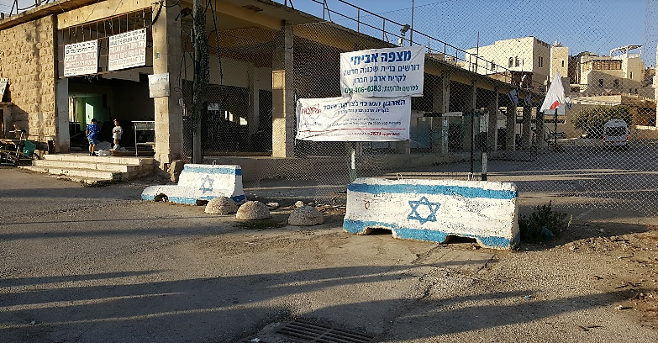

Student: Semra Altuntas (1018078)
Supervisor: Mr. H.D. Roskam-Dam
Research question: "To what extent does the establishment and expansion of the Israeli settlements in the West Bank violate Article 49 (paragraph 6) of the Fourth Geneva Convention, and what are the legal consequences of such a violation for Israel and third States?"
Date: 16-07-2017
Total words: 14,990 (including footnotes)
12,313 (excluding footnotes)

Name: Semra Altuntas
Address: Dr. Wiardi Beckmansingel 265, 3132CR Vlaardingen.
Student number: 1018078
Telephone number: 0648988351
Email address: semra_ruveyda@hotmail.com
Academic programme: L.L.M. Public International Law (2016-2017)
Supervisor: Mr. H.D. Roskam-Dam
Pages: 55
Table of contents
1. Introduction 3
1.1. Spatial and temporal scope 4
1.2. Research and sub-questions 5
1.3. Maps 7
2. The law of occupation 9
2.1. Introduction 9
2.2. The framework of the law of occupation 10
2.2.1. The Hague Regulations 10
2.2.2. The Fourth Geneva Convention 13
2.3. The Israeli position 14
2.4. Facts on the ground 16
2.5. Conclusion... 21
3. The Israeli Settlements in the West Bank 22
3.1. Introduction 22
3.2. Article 49 (paragraph 6) of the Fourth Geneva Convention 22
3.3. The Israeli arguments to legalise Settlements 28
3.4. A case study: Hebron 32
3.5. Conclusion 38
4. Legal consequences 39
4.1. Introduction 39
4.2. Legal consequences for Israel 40
4.3. Legal consequences for third States 44
4.4. Conclusion 46
5. Conclusion 47
6. Bibliography 48
Books 48
Treaties and conventions 50
United Nations Documents 50
Commentaries 51
Official documents 51
Journal articles 51
Internet sources 52

Introduction
The Palestinian-Israeli conflict – as a product of developments in the entire region – is a conflict which unfortunately does not seem to come to an end soon. The year of 2017 symbolises 120 years of Zionism, one century anniversary of the Balfour-declaration which promised Jews a home in Palestine, 70 years since the 1947 United Nations (UN) Partition Plan and 50 years of the occupation of Palestinian territories.
The first Jewish populations inhabited only some parts of Palestine and lived side by side and peacefully with the Arabs. But especially after the Holocaust more and more Jews sought a safe home in Palestine based on their right in the Balfour Declaration. By 1947, the Jewish movement to Palestine caused such a change in the demography of the country, that the United Nations General Assembly (UNGA) adopted the 1947 Partition Plan. The neighbouring Arab countries (Egypt, Syria, Jordan, Lebanon and Iraq) did not agree upon this plan due to its imbalance. The UN Partition Plan gave 56 percent of the land to Jews which were still a large minority of 33 per cent and 43 per cent of Palestinian land to the Arabs. The remaining 1 percent was Jerusalem which was a corpus seperatum, belonging to neither the Jews nor the Arabs. This plan led to a war between Arabs and Jews which the Arabs lost. The Jews who won the war then established Israel by the Declaration of Establishment of the State of Israel (14 May 1948). Armistice Agreements were established between the newly established Israel and these countries except Iraq. Palestine became divided into three parts being a) Israel (including West Jerusalem); b) the West Bank (including East Jerusalem) which was then occupied by Jordan; and c) the Gaza Strip which was then occupied by Egypt.
Only since the occupation of 1967 Jews started moving to the occupied Palestinian areas by way of settlements built by the Israeli government which is the subject matter of this thesis.

1.1. Spatial and temporal scope
In this thesis, the Israeli settlements in the West Bank are analysed on their compliance with Article 49 (paragraph 6) of the Fourth Geneva Convention. The West Bank is part of Palestine and lies between Israel and Jordan. The exact borders of the West Bank can be found in the Israel-Jordan Armistice Agreement. According to this agreement some of the Palestinian villages from the West Bank – as defined in the UN Partition Plan – became part of Israel.
The West Bank remained under Jordanian occupation until 1967. Only after 1967, Israel occupied the West Bank and took over its military control after the Six-Day War. Article 49 (paragraph 6) of the Fourth Geneva Convention is part of the law of occupation and therefore only applies when there is a de facto occupation. This thesis discusses the Israeli settlements based on the occupation of the West Bank since the 1967 Six Day War.
Although Gaza is also part of Palestine since the disengagement of the Israeli Defence Forces (IDF) from the Gaza Strip in 2005, the Israeli settlements in the Gaza Strip are dismantled. Therefore the Gaza Strip will not be part of this thesis.

1.2. Research and sub-questions
This conflict is for sure highly sensitive and controversial, thus can be discussed from different perspectives as philosophical, religious or humanitarian. However, the anniversaries as mentioned above, the recent UN Security Council (UNSC) resolution 2334 and Israel's response by retroactively legalising some of the settlements by its national law (the Regularisation Bill) make it necessary to discuss the Israeli settlements in the West Bank (also) from a legal perspective. This thesis, therefore, is based on the following research question:

"To what extent does the establishment and expansion of the Israeli settlements in the West Bank violate Article 49 (paragraph 6) of the Fourth Geneva Convention, and what are the legal consequences of such a violation for Israel and third States?"

This question is analysed through three sub-questions to be discussed in separate chapters, which are the following:

- Why is the Fourth Geneva Convention applicable in the West Bank?

Chapter Two analyses the applicability of the Fourth Geneva Convention in the West Bank. Although the Fourth Geneva Convention itself does not provide a definition of occupation, the definition as provided in the Hague Regulations suffice for the purpose of this thesis. This choice is legitimate because the Hague Regulations – as part of the law of occupation and reflecting customary international law which is binding upon all states – do apply in the West Bank.
Hence, this Chapter explains why the West Bank is (still) occupied and why therefore the Fourth Geneva Convention applies in the West Bank.

2) Are the establishment and expansion of the Israeli settlements violating Art. 49 (paragraph 6) of the Fourth Geneva Convention?

Chapter Three analyses Art. 49 (paragraph 6) of the Fourth Geneva Convention, which prohibits the massive relocation of the population of the occupant into the occupied territories. This Chapter discusses whether this is the case regarding (all of) the settlements in the West Bank and whether the Israeli arguments legalising the settlements are lawful (e.g. military purpose, national laws, bilateral agreements).
Subsequently, the particular case of the settlements in Hebron and their functions are analysed in order to visualise the issue by way of a case study.

3) What are the legal consequences of a violation of Art. 49 (paragraph 6) for Israel and for third States?

Chapter Four discusses the legal consequences for Israel violating Article 49 (paragraph 6) and also the legal consequences for third States witnessing this violation.
Whereas the Fourth Geneva Convention itself only provides for penal sanctions for the State violating its obligations under the Convention (Art. 146), the Articles on the Responsibility of States for Internationally Wrongful Acts (2001) (ARSIWA) allows the injured State and other States to invoke Israel's international responsibility for the violation of any international obligation (Art. 42 and 48).
On the other hand, the UNSC can act under Chapter VII in order to enforce Israel to comply with its international obligations, and the International Court of Justice (ICJ) laid down the legal consequences of such a violation – both for the violating State and third States – in the Namibia case and the Wall AO.

1.3. Maps
The maps below provide a visual image of how the settlements activities in Palestine have evolved since 1947. It shows the ratio between Israeli and Palestinian lands since right before the UN Partition Plan until today.
The word settlement in the first map of 1947 (left) does not imply that settlements as in the meaning of this thesis existed even before the 1967 Occupation and the UN Partition Plan. In fact, Jews were always present in Palestine, even before the Holocaust and the Balfour Declaration. Hence, Jewish Settlements in this picture does actually mean that Jews were more concentrated in those places.
The map on the present situation shows the current division in the West Bank, which is largely occupied by Israel.

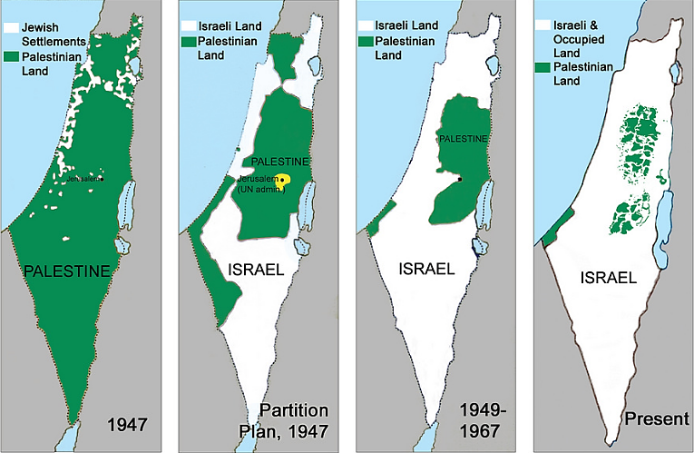
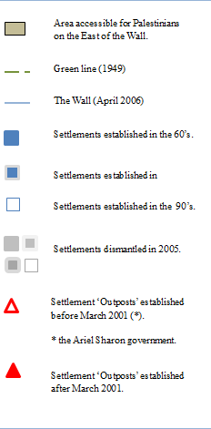
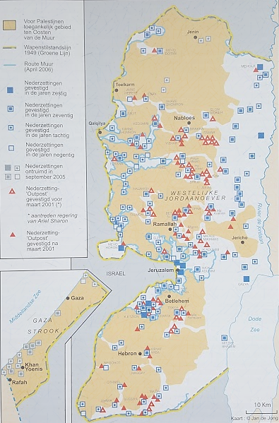
The map below shows the development of the settlement activities in the occupied Palestinian territories since the sixties:

The law of occupation

Introduction
This Chapter explains why the Fourth Geneva Convention as part of the law of occupation is applicable in the West Bank. However, the discussion regarding the legality of an occupation is excluded. The question of legality is part of jus ad bellum which is about the recourse to armed conflicts, whereas the law of occupation as part of jus in bello – or international humanitarian law – provides the rules during an armed conflict and occupation. Besides, the legality of an occupation does not influence the applicability of the law of occupation which is based on facts on the ground instead of the reasons and motivation behind an occupation. For these reasons, the legality of the Israeli occupation is not discussed in this thesis.
The law of occupation is applicable when there is a de facto occupation. Before Art. 49 (paragraph 6) of the Fourth Geneva Convention is analysed and discussed, this Chapter explains why the West Bank is de facto under occupation and why the Fourth Geneva Convention is accordingly applicable. As mentioned above, the definition of an occupation as provided in the Hague Regulations is analysed and applied to the West Bank. Subsequently, the applicability of the Fourth Geneva Convention is discussed, for this Convention explicitly prohibits the establishment and expansion of settlements. An important part of this discussion is the Israeli position because although Israel is party to the Convention, it does not accept its applicability in the West Bank. The lawfulness of the Israeli arguments according to international law is thus analysed. Finally, the facts on the ground bring this Chapter to the answer of the first sub-question why the West Bank is indeed (still) under occupation.

The framework of the law of occupation
The law of occupation contains four legal sources: a) customary international law; b) Hague Regulations; c) Fourth Geneva Convention, and d) Additional Protocol I to the Fourth Geneva Convention (Protocol I).
Customary international law is – as far as relevant for this thesis – codified in the Hague Regulations and is therefore not separately discussed hereafter. Furthermore, Protocol I is not ratified by Israel and is, therefore, neither discussed thoroughly. However, Article 4 of Protocol I – which prohibits land annexation – is discussed in Chapter Three, as it has ‘uncontested principle of international law’ status and therefore is binding upon all states, whether they are party to the Protocol or not.

The Hague Regulations
The binding force (as customary international law) of the Hague Regulations on all states – whether States Parties or not – is confirmed by many scholars, the ICJ, the International Military Tribunal of Nuremberg, the International Court of the Tribunal for Yugoslavia (ICTY) and even the Israeli Supreme Court. Section III of the regulations contains the rules on occupation and defines occupation as follows:

“Territory is considered occupied when it is actually placed under the authority of the hostile army. The occupation extends only to the territory where such authority has been established and can be exercised.”

Two conditions for occupation derive from this Article, a) the establishment of effective control of the occupying power over the occupied territories based on facts on the grounds and b) the ability to enforce this control within a reasonable time when and where it is necessary. Although the exact substance of these conditions does not necessarily derive from this mere Article, hereafter they are explained secondary sources and judgements.

Effective control
Effective control is the first and most important condition to determine the existence of an occupation. On the other hand, the actual enforcement of control through the presence of armed forces – once control is established – is less relevant, because it is enough that the occupant can make its authority felt when it deems necessary.
In this regard, the ICTY laid down some important guidelines which may ‘provide some assistance’ to establish effective control. The ICTY thereby uses a broad interpretation of Art. 42. The wordings of the ICTY indicate that this list is neither exhaustive nor do all the guidelines need to be fulfilled to establish effective control. However, as constitutional laws do not give such a guiding list to determine the existence of effective control – which is decisive to establish the existence of an occupation – these guidelines give an important support to do so. The guidelines of the ICTY are as follows:

- The occupying power must be in a position to substitute its own authority for that of the occupied authorities, which must have been rendered incapable of functioning publicly;
- The enemy’s forces have surrendered, been defeated or withdrawn. In this respect, battle areas may not be considered as occupied territory. However, sporadic local resistance, even successful, does not affect the reality of occupation;
- The occupying power has a sufficient force present, or the capacity to send troops within a reasonable time to make the authority of the occupying power felt;
- A temporary administration has been established over the territory;
- The occupying power has issued and enforced directions to the civilian population.

Whereas the ICTY uses a broad interpretation of Art. 42, the ICJ interpreted article 42 more strictly in the Armed Activities case regarding the exercise of authority and chose actual control over potential control. However, this approach of the ICJ is not widely supported because this way of interpretation gives less protection to civilians under (potential) occupation. Besides, according to Benvenisti, this way of strict interpretation of Article 42 is not in line with the Travaux préparatoires of the Hague Regulations and previous jurisprudence of the ICJ.
Nevertheless, even if this strict approach would be widely supported, the determination of occupation remains a matter of facts on the ground in which the guidelines of the ICTY are useful. Noteworthy is that the control shall be over a territory instead of a population in accordance with the nature of the Hague Regulations which concerns inter-state relations rather than humanitarian purposes. However, this does not take away that the occupant becomes responsible over the population after occupying the territory they live in.

Ability to enforce
The second condition of occupation is by main scholars interpreted as the occupant being in the position to enforce effective control (potential authority), whether it does or not enforce its control is of less relevance. The physical presence of armed forces is not a requirement per se if the military can be present when necessary to make the occupants’ autonomy felt. The US Military Tribunal confirms this, ‘To the extent that the occupant’s control is maintained and that of the civil government eliminated, the area will be said to be occupied’.
Concluding, according to the Hague Regulations, an occupation exists if there is effective control by the occupant over the occupied territories based on facts on the ground. The facts on the ground in the West Bank are analysed in section 2.4.

The Fourth Geneva Convention
The applicability of the Fourth Geneva Convention derives from Article 2 which provides that the Fourth Geneva Convention applies to:

“[…] all cases of declared war or any other armed conflict which may arise between two or more of the High Contracting Parties, […] (paragraph 1). The Convention shall also apply to all cases of partial or total occupation of the territory of a High Contracting Party, even if the said occupation meets with no armed resistance (paragraph 2).”

Thus, in situations of occupation or declared armed conflicts the Fourth Geneva Convention shall in principle apply to protect civilians (those who are under the authority of the hostile army). As emphasised in the title of the Fourth Geneva Convention, the level of protection of civilians has increased in importance by this Convention, because the protection of civilians is the main object and purpose of the Fourth Geneva Convention. Therefore, according to the ICJ in the Wall advisory opinion, it is sufficient that civilians have somehow come under the authority of a foreign power.
Provided that both Israel and Palestine ratified the Fourth Geneva Convention, its provisions are binding upon both. In principle, Article 2 (paragraph 1) of the Fourth Geneva Convention suffices to apply the Fourth Geneva Convention in the Palestinian-Israeli conflict. For this paragraph contains two conditions, namely 1) the existence of an armed conflict; and 2) the existence of at least two States Parties to the Convention. According to these requirements, the Fourth Geneva Convention started applying during the Six-Day War in 1967 between, inter alia, Jordan and Israel which are both States Parties to the Convention since 1951. As Palestine was under the sovereignty of Jordan between 1948 and 1967, the 1967 Occupation as a result of the Six-Day War created a situation of Article 2 (paragraph 1) of the Fourth Geneva Convention.
Also, the Fourth Geneva Convention is through ratification by 196 States regarded to be universally accepted which makes it universally binding as treaty law as well as part of customary international law which is binding upon all States. This approach is also supported by the ICJ and the Secretary-General of the UN in 1993. The customary international law character of the Fourth Geneva Convention can also be implied from Article 154 Fourth Geneva Convention which provides that this Convention is supplementary to the sections II and III of the Hague Regulations. Its supplementary character does not mean that the Fourth Geneva Convention itself is also customary international law, yet it is a strong indication of the intention of the makers of the Convention in that direction. As discussed above, The Hague Regulations codify customary international law and Section III deals with the rules on occupation. Hence, if there is occupation per Article 42 of The Hague Regulations, the Fourth Geneva Convention is in principle applicable in the occupied Palestinian territories.

The Israeli position
Israel does not refuse the applicability of the Hague Regulations, as it is a reflection of customary international law binding upon all states. Neither does it deny that it occupies the Palestinian territories in the West Bank, therefore, this section only discusses its position regarding the Fourth Geneva Convention. In this regard, the ICJ discussed the Israeli position on the applicability of the Fourth Geneva Convention in the Wall advisory opinion, which is as follows:

‘…Israel does not agree that the Fourth Geneva Convention is applicable to the occupied Palestinian territories […] the lack of recognition of the territory as sovereign prior to its annexation by Jordan and Egypt […] it is not a territory of a High Contracting Party as required by the Convention.’

The ICJ determines first that both Israel and Jordan – as the previous occupying power of the Palestinian territories – ratified the Fourth Geneva Convention without any reservations in 1951. In 1982, Palestine (unilaterally) declared the applicability of the Fourth Geneva Convention. Palestine’s territorial status prior to Jordan’s annexation is not relevant as the occupation is a result of the 1967 War when Jordan lost sovereignty over the West Bank and Israel occupied these territories.
In Israel’s view, Palestine is not a ‘High Contracting Party’ as required in Art. 2 (paragraph 2) of the Fourth Geneva Convention, for Israel does not recognise Palestine as a State. Israel thereby interprets this Article very restrictive, whereas the ICJ’s approach is much broader. The ICJ uses the interpretation methods as provided in the Articles 32 and 33 of the Vienna Convention. According to this interpretation, Article 2 is a treaty provision and should be interpreted on its object and purpose and not on its mere wordings. The main object and purpose of the Fourth Geneva Convention are the protection of civilians who are under responsibility of a foreign power. Furthermore, Art. 2 (paragraph 2) of the Convention states that even if there is only one State Party to the Fourth Geneva Convention involved in the proceedings, it remains applicable for that one State Party. The main reason, therefore, is that the protection of civilians who are under occupation – in one way or the other – prevails above the interests of States and the status of the occupied territory. The law of occupation – as part of international humanitarian law – is a purely humanitarian and, therefore, applies in every case of occupation, despite the other facts or political interests.
As a final remark, the ICJ cites an Israeli Military Order which is adopted after the occupation in 1967 that reads as follows:

"The Military Court […] must apply the provisions of the Geneva Convention dated 12 August 1949 relative to the Protection of Civilian Persons in Time of War with respect to judicial procedures. In case of conflict between this Order and the said Convention, the Convention shall prevail."

By this Military Order, Israel accepts the applicability of the Fourth Geneva Convention and even decides that it shall have primacy over this Order when there is a conflict with the Convention. Hence, that Israel still does not accept to apply the Fourth Geneva Convention in the Palestinian-Israeli conflict is odd, and violates its own Military Order.

Facts on the ground
This section analyses the de facto situation in the West Bank to explain why it actually is under occupation. Therefore, the relevant facts that determine the potential control over the territories will be analysed in the light of the guidelines of the ICTY.

The division and administration of the West Bank: Area A, B and C
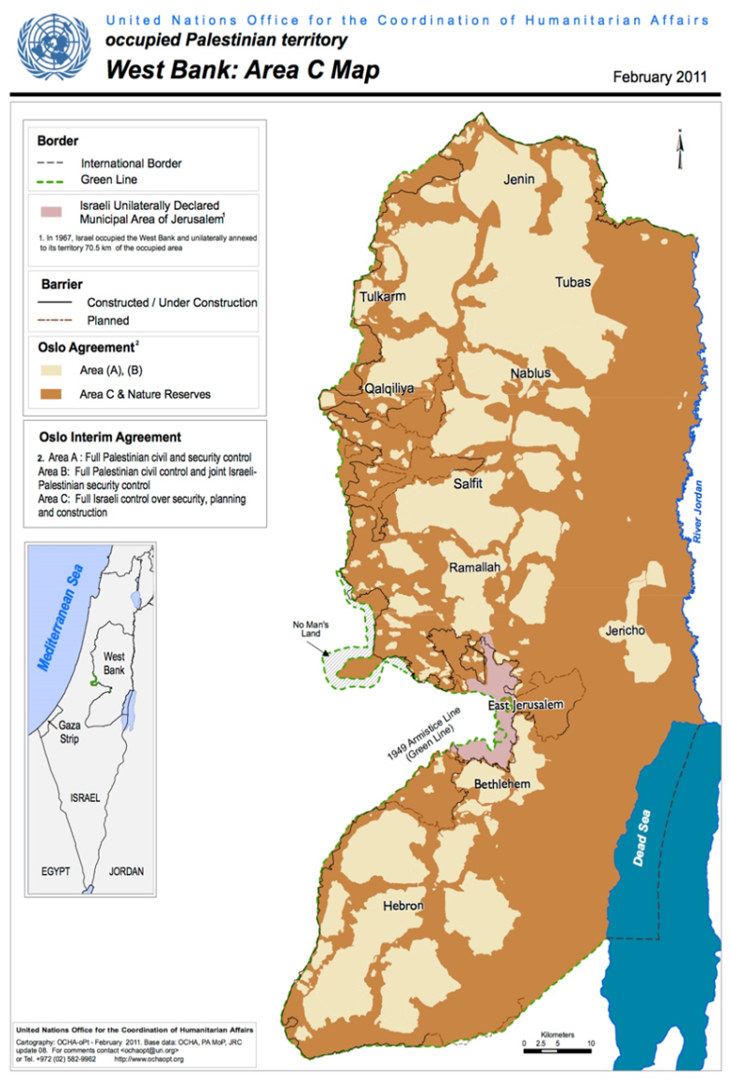
Before the Oslo Accords – that is between 1967 and 1993 – the West Bank was under full civil and military control of Israel. However, the Oslo Accords gave limited authority to the Palestinian Authority (PA) that was newly established by then. Thereby the West Bank was divided into three areas. According to this division, Israel has control over a big part of the West Bank, which is called Area C. The map on the left visualises the different areas and shows that the West Bank is for approximately 80 percent under Israeli control and for 20 percent under Palestinian control. Hereafter the different Areas are analysed as to their authorities and the de facto situation.

- Area A, which makes about 18 percent of the West Bank is under full authority of the PA. This area contains entirely Palestinian cities (Hebron, Nablus, Ramallah, Bethlehem) separated by areas controlled by Israel, including checkpoints, settlements and military outposts. Palestinians living in this area need to cross Israeli checkpoints every time they want to leave or enter the city they live in. The Palestinian civil and security governance in this area is only within the cities, whereas Israel maintains the final authority over its borders. The Israeli government placed red signs at the entrances to Palestinian cities which inform Israeli citizens that entrance is prohibited for Israelis by Israeli law and also dangerous for their lives.

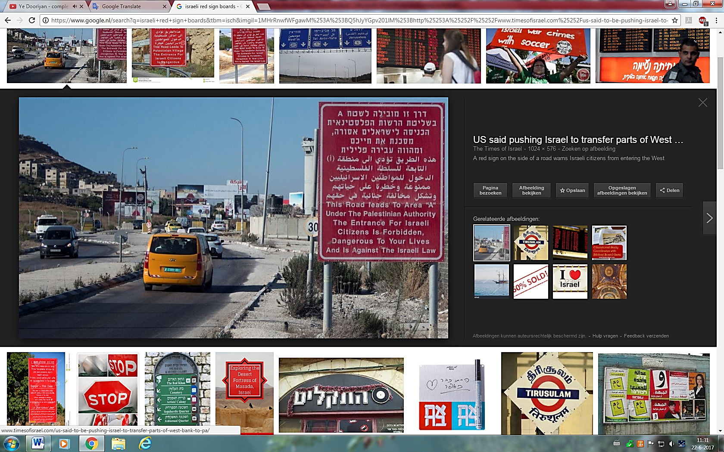

A red sign on the side of a road warns Israeli citizens from entering the West Bank city of Nablus on July 29, 2015. (© Garrett Mills).

- Area B, which makes about 22 percent of the West Bank is under Palestinian civil administration and under Israeli security/military control with limited cooperation from the Palestinian police. Area B has more than 400 villages and farmland, mostly threatened by the expansion of Israeli settlements into Palestinian land.
- Area C, which is the biggest part of the West Bank, makes about 60 percent of the West Bank and is under full Israeli control. The PA has the sole responsibility to provide education and medical services to the approximately 300,000 Palestinians living there. Almost all Israeli settlements – 125 settlements and approximately 100 outposts for military training – are established in this area, while Palestinians who live in this area depend on building permits from Israel, which is heavily restricted. Buildings without permits result in demolition orders.
Furthermore, water supply in this area is regulated by Israel. In this regard, according to the UNOCHA, more than 70 percent of the Palestinian villages in this area have irregular access to the water network, whereas the Israeli settlements continuously have access to fresh water. Palestinian houses can, therefore, easily be separated from the Israeli settlements as they have huge black water tanks on their rooftops to solve their water problem.
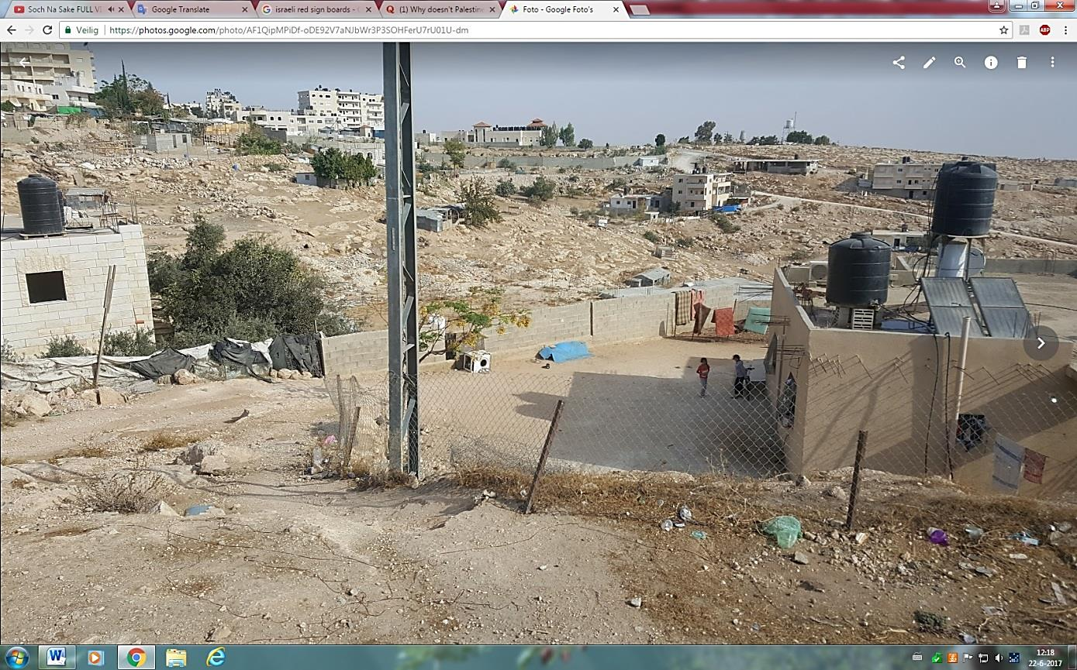
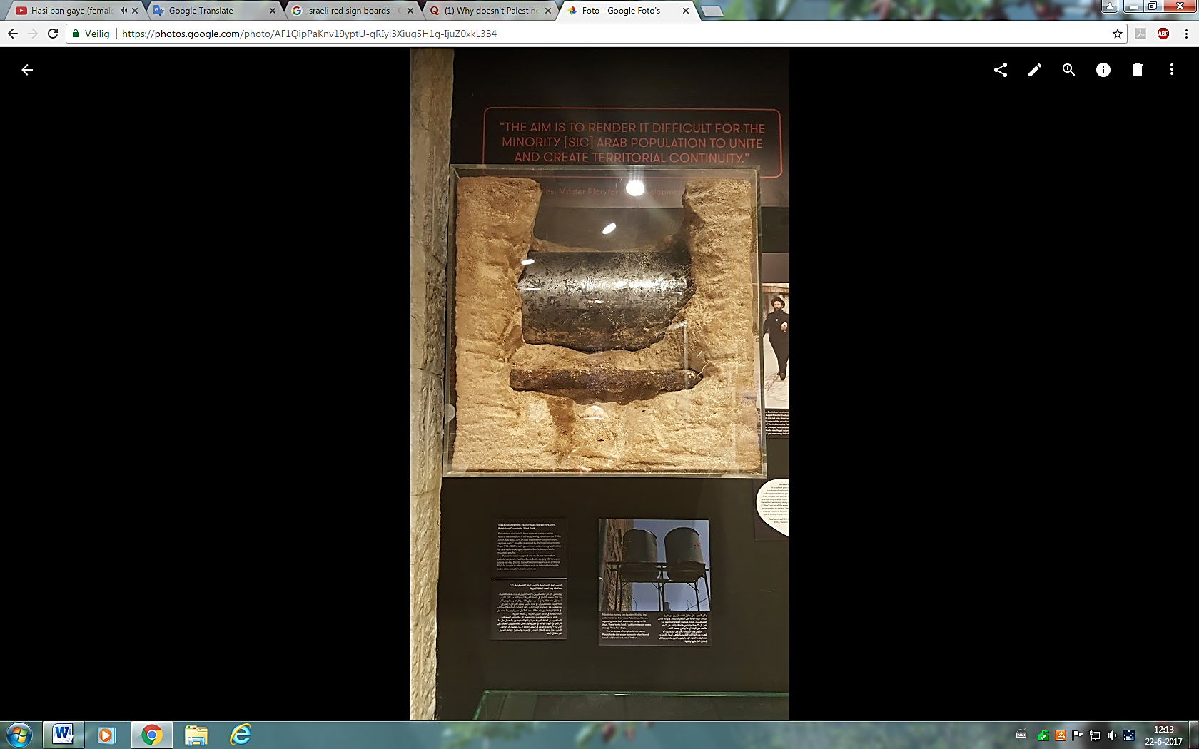
Water tanks on the rooftop of a Palestinian house in a Palestinian village in Area C (November 2016).
The upper water pipe is for water supply to Israeli settlements, while the lower water pipe is for water supply to the Palestinian villages in area C (March 2017).

This division and administration section briefly shows that – in fact – Israel has almost exclusive control over approximately 80 percent of the West Bank and, to some extent, also over the other 20 percent. It is in the position to substitute its own authority for that of the PA, because de facto it already did through the IDF which is spread over 80 percent of the West Bank (Areas B and C). Moreover, the Israeli government can issue and enforce directions to the Palestinians, as it already did on many issues of their daily lives (e.g. movement, construction, education).

New Israeli Policy regarding the West Bank: ‘Carrot and Stick’
The Israeli Defense Minister Liberman – in coordination with Israeli Prime Minister Benjamin Netanyahu – introduced the so-called ‘Carrot and Stick’ policy in August 2016 which will give Israel full control over the West Bank. Thereby, the West Bank will be divided into three parts in which green areas will represent the areas where no (alleged) Palestinian ‘terrorists’ come from, while red and yellow will represent a smaller part – mainly around Hebron – where (alleged) Palestinian terrorists do originate from. The main Israeli newspaper The Jerusalem Post explains this policy as follows:

‘The means of punishment for areas from where terrorism originates will include increased IDF activity in Area A of the West Bank; home demolitions; increased arrests; raids on homes from which terrorists came; confiscation of terrorism funds and property; cancellation of VIP permits for senior Palestinian Authority officials taking part in incitement; increased vehicle searches at the Kalandiya refugee camp; and stricter enforcement against illegal building.’

On the one hand, this is a way of collective punishment which is in violation of the Fourth Geneva Convention. On the other hand, this policy indicates Israel’s intention to keep full control over the West Bank for an unlimited period taken into account the current practice in the region as Prime Minister Netanyahu says, ‘one must understand that in any future arrangement with the Palestinians, Israel must maintain security control of the area up to the Jordan River for a very long time’.

Military presence
Provided that Palestine does not have a military force of its own, the only military presence in the West Bank belongs to Israel. Historically, Palestine was part of the Ottoman Empire and considered the Ottoman army as its army. After being part of the Ottoman Empire, it fell under British mandate and therefore still had no own army. After the British mandate, Palestine was always occupied – first by the neighbouring Arab States and then by Israel – hence, Palestinians never had their own army as such. Currently, the issue of a Palestinian army has to be finalised by the Oslo Accords, which is a bilateral agreement between Israel and Palestine. However, although they are not finalised yet, the parties have neither been negotiating on the Oslo Accords since 2000.
On the other hand, the Israel Defence Forces (IDF) is omnipresent in the West Bank for alleged security reasons. Checkpoints, settlements and bus stops for settlers are always equipped with IDF militants. Many times they are also present at arbitrary points of Palestinian roads in Area A to check the driver’s identity card, as the holders of a ‘green’ identity card are not allowed to leave Area A without permission from Israel.

The Palestinian identity card (ID)
A brief clarification regarding the Palestinian ID is needed, as it establishes another means of Israeli control over Palestine. For there is more than one Palestinian ID. First of all, Palestinians born in the West Bank after 1967 have a green ID, while those who are born in the West Bank before 1967 usually have a Jordanian or Egyptian ID depending on the country that issued them citizenship. The Palestinians who happened to live in the areas that became Israel after 1948 have either the Israeli citizenship or a blue ID depending on their own choice. Noteworthy is that Palestinians with Israeli citizenship are obligated to serve in the IDF, while holders of a blue ID do not. Also, Palestinians from Jerusalem always have a blue ID. Whereas the holders of a blue ID can travel freely through both Israel and the Palestinian territories, the holders of a green ID – which makes the majority of the Palestinians – are not allowed to enter Jerusalem or Israel.
However, all of these Palestinian ID’s are only residence permits, hence, they do not give Palestinians full citizenship nor is it a legitimate travel document. To travel abroad, Palestinians need a visa from the Israeli government and cannot use the international airport of Tel Aviv.

Conclusion
Concluding, Israel is in the position to enforce effective control over the West Bank and therefore is occupying it as in Art. 42 of the Hague Regulations. Therefore, this Chapter establishes that the West Bank is (still) under the de facto occupation of Israel. For the reasons set out in this Chapter, the law of occupation and the Fourth Geneva Convention are thus applicable in the Palestinian-Israeli conflict. Hence, Chapter Three answers the second sub-question whether the establishment and expansion of the Israeli settlements do violate Art. 49 (paragraph 6) of the Fourth Geneva Convention.

The Israeli Settlements in the West Bank

Introduction
Chapter Two establishes that the West Bank is (still) under occupation and, therefore, both the law of occupation and the Fourth Geneva Convention are applicable in the West Bank. This Chapter thus answers why the establishment and expansion of the Israeli settlements are violating Art. 49 (paragraph 6) of the Fourth Geneva Convention.
Firstly, this Article is analysed as to its object and purpose and on whether it allows potential exceptions (e.g. military purpose, bilateral agreements, national laws). Subsequently, the Israeli arguments regarding the legal status of the settlements are analysed and discussed in the light of these potential exceptions. Finally, the case of Hebron is analysed to discuss the de facto purpose of the Israeli settlements in this governance and whether they form a breach of Art. 49 (paragraph 6).
Hebron is the biggest governance of the West Bank and hosts the greatest amount of settlements. Since the Goldstein massacre of 1994, the city centre of Hebron is closed for Palestinians in its entirety.

Article 49 (paragraph 6) of the Fourth Geneva Convention
The deportation or transfer of (parts of) the population of the occupant to the occupied territories is prohibited per article 49 (paragraph 6) of the Fourth Geneva Convention.
The use of both the wordings transfer and deport and the elimination of the wording forcible in paragraph 6 – comparing to the previous paragraphs of the Article – must first be analysed from a linguistic point of view. Indeed, one cannot be considered a deportee when it leaves a territory voluntarily. Deportation implies the forceful action by the occupant to remove a person from its own territory, whilst a transfer – which is not forceful as in the previous paragraphs of Article 49 – implies a voluntary leave of the territory of the occupant. Hence, paragraph 6 prohibits the transfer or deport of the civilian population of the occupant to the occupied territories, either forcefully (directly) or voluntarily (indirectly).

Object and purpose
According to Dinstein, although paragraph 6 does not explicitly say so, this paragraph equally applies for the transfer or deportation of nationals of co-belligerent or neutral States, if this happens purposely to create a demographic change in the occupied territories or harms the existence of the native inhabitants in any way.
Paragraph 6 follows after five paragraphs of protecting the people who are forcefully transferred or deported to elsewhere. In these five paragraphs, the transferred or deported people themselves are the subjects being protected. However, in paragraph 6 the transferred people are nationals of the occupant who do not belong to the group of protected persons under the Fourth Geneva Convention, regardless whether they are deported or transferred. Instead, the transferred or deported people in the context of paragraph 6 are the ones that form a threat to the existence of the population in the occupied territories. Thus Art. 49 (paragraph 6) protects the latter group, regardless whether they are displaced or not. It might, therefore, be more logic if Art. 49 (paragraph 6) should be separated from the first five paragraphs as a provision in itself, for its misplacement creates confusion as to its purpose and application.
Indeed, Art. 49 (paragraph 6) does not prohibit the placement of civil servants or officials of the occupant in the occupied territories to assist its established military government, as long as this is on a temporary and a functional basis. Neither does this paragraph explicitly prohibit the movement of individual Israelis to the occupied territories on their own initiative and without any direct or indirect support of the occupant, as long as they respect the local laws and culture of the native people and do not intend to harm them in any way. For the logic behind Art. 49 (paragraph 6) is to prevent colonialism in order to gain land permanently from occupied territories, yet not to prevent immigration at all. However, the different lifestyles between the native people in the occupied territories and the nationals of the occupant can cause cases of discrimination or in any other way deteriorate the lives of the native people, which is not and should not be the aim of an occupation. Yet this would not necessarily be the case if individual Israelis move to the occupied territories on their own initiative without the support of the occupant.
Broader context: Rome Statute and Protocol 1
Although Israel has not ratified them, Protocol I and the Rome Statute are highly relevant to understand the broader context of Art. 49 (paragraph 6) from an international law perspective.
In this regard, Art. 85 (4) (a) of Protocol I incorporates this prohibition to the list of grave breaches of international law and Art. 8 (2) (b) (viii) of the Rome Statute classifies as a war crime the “transfer, directly or indirectly, by the Occupying Power of parts of its own civilian population into the territory it occupies”. The Rome Statute adds for the first time explicitly that also the indirect transfer of the own population of the occupant is a violation of Art. 49 (paragraph 6). The indirect transfer is the inducement and facilitation of a living which attracts the nationals of the occupant to live in the occupied territories and thus violates Art. 49 (paragraph 6). The transfer by the occupant of its own nationals into the occupied territory violates the principle of international law that an occupant is only permitted to a ‘position of trust as an interim military administrator’. According to Cryer, this addition in the Rome Statute was particularly related to the Palestinian-Israeli case.
The ICJ confirms this way of a broader interpretation of Art. 49 (paragraph 6) in the Wall advisory opinion:

“That provision prohibits not only deportations or forced transfers of population such as those carried out during the Second World War, but also any measures taken by an Occupying Power in order to organize or encourage transfers of parts of its own population into the occupied territory”.

As Israel is indeed not bound by the provisions of Protocol I and the Rome Statute as a non-member State and an advisory opinion of the ICJ is not binding as such, one must look into the mere wordings of Art. 49 (paragraph 6) in the context of the Fourth Geneva Convention alone, as analysed above. Yet the general international principle of good faith requires that Israel should take this broader context of international law regarding Art. 49 (paragraph 6) into account if it would comply with this Article. However, the discussion about good faith is of later concern as Israel does not accept the applicability of the Fourth Geneva Convention in its entirety.

Potential exceptions to Art. 49 (paragraph 6)
This section discusses the Israeli practice to establish settlements – the seizure of land from occupied territories to build on – and whether this is in conformity with the law of occupation.
In this regard, the Hague Regulations allow the seizure of land for military purposes alone per Art. 46, as the occupant is entitled to establish a military government in the occupied territories. Art. 46 (2) of the Fourth Geneva Convention confirms the Hague Regulations’ principle that movable and immovable goods can be used for military purpose or security needs alone. However, the Hague Regulations provide that it is impossible “to concert Regulations covering all the circumstances which arise in practice”, yet that should not mean that ”unforeseen cases should, in the absence of a written undertaking, be left to the arbitrary judgment of military commanders”. Hence, the exception of military purpose is as well limited in itself.

The Israeli Supreme Court
The exception of military purpose is also confirmed and further explained by the Israeli Supreme Court in the Abu Rian case. The Supreme Court states that, although the Hague Regulations do not explicitly provide for the seizure of immovable private properties (e.g. lands), it is undeniable that the occupant should not be allowed to take temporary possession of private lands for military purposes, subject to compensation. The Supreme Court lays down three cumulative conditions to such seizure – if the seizure is for military purpose at all – in the Juha case:

- It must be for a fixed time, although the period may subsequently be extended as long as the occupation lasts (temporality);
- The owner is automatically entitled to payment of compensation for the use of the property, or land (compensation);
- Should any damage be caused to the property (e.g. cutting of trees), this is also subject to compensation.

In the Beth El and the Elon Moreh cases of the Israeli Supreme Court (1979), the Court examined the claims of the Palestinians – whose private lands were seized by Israel to establish settlements – in accordance with the Hague Regulations as this is a reflection of customary international law which is binding upon all States. In the Beth El case, the settlements were indeed established for military purposes, while in the Elon Moreh case the settlements were established for civilian purposes to be used permanently. Eventually, the (civilian) settlements in the Elon Moreh case were dismantled because they were established unlawfully neither military purpose nor temporary). The compensation they offered to the private owners of the lands was not sufficient to accept their claim on the lands, for the above-mentioned conditions of the Juha case are cumulative. However, when settlements are established for military purposes and are subject to compensation, the temporality is logically being assumed.
In both cases, the Court first considered that Art. 46 (paragraph 2) of the Hague Regulations prohibit the confiscation of private property in its entirety, ‘private property cannot be confiscated’. Yet subsequently, the Court made a distinction between an impermissible seizure of private land and a permissible seizure of private land. Confiscation appears to be impermissible when it happens unlawfully (not for military purposes), whilst a permissible seizure happens when it is for temporary use (without deprivation of ownership), for military purposes, and subject to compensation. Most of the Israeli settlements in the West Bank established between 1967 and 1979 are built for military purposes.

Principle of distinction
The exception of military purpose became problematic when the Israeli Supreme Court started interpreting it very creatively.
For instance, a civilian settlement got a military dimension because ‘Israeli men and women of military age serve as reservists for the IDF’, regardless whether there were also civilians in those settlements not of military age. Another example was that of the civilian settlements on a hilltop with a view of the Ben Gurion International Airport. In this case, the settlements got a military dimension because they were a ‘potential lookout post facilitating military protection of this sensitive strategic point’. This practice of the Israeli Supreme Court alters the principle of distinction between combatants and civilians and also takes Art. 46 of the Hague Regulations out of its context. If civilian settlements get a military dimension by an extremely creative interpretation of the exception to Art. 46 of the Hague Regulations, they would be exposed to lawful attacks being a military objective according to international humanitarian law. This would deteriorate the protection of civilians.

Land annexation, Art. 4 Protocol I
An occupant might de facto and temporarily possess occupied territories for military purpose, yet it does not retain their title de jure. This principle makes the annexation of occupied lands illegal in its entirety under international humanitarian law because otherwise, the occupant would permanently gain de jure title over the territories it occupies which is not permitted. The prohibition of land annexation is codified in the Fourth Geneva Convention and Protocol I.
Although Protocol I is not binding upon Israel, Art. 4 of Protocol I – prohibiting land annexation – has the status of ‘uncontested principle of international law’ and is therefore still binding upon Israel. Besides, the UNSC, the ICJ and the Supreme Court of Israel have all confirmed that Israel never did – nor ever could – change the legal status of the occupied territories. Therefore, every attempt to annex lands from the occupied territories to gain de jure title over them is (and shall be) null and void. Logically, Israel cannot build permanent settlements on lands which it does not (permanently) possess. Oppenheim says in this regard that, ‘There is not an atom of sovereignty in the authority of the Occupying Power’.

The Israeli arguments to legalise Settlements
Since the occupation of 1967 Israel – by military law – implemented the arguments below in order to seize Palestinian land:

- Declaring land to be absentee property;
- Declaring land to be the property of a hostile state;
- Confiscating land for public needs;
- Declaring land to be part of nature reserves;
- Requisitioning land for military needs;
- Declaring land to be state property.

The first five methods were especially used between 1967 and 1980, yet between 1981 and 1987 the first two were replaced with the sixth method. Absentee property is the ‘property whose legal owner […] left the area prior to 7 June 1967 or subsequently’. Hence, Palestinians who left their homes due to the Six-Day War lost their lands permanently. Only in the first few years of the occupation, approximately 7,5 percent of the West Bank became part of Area C – which is under Israeli control – as absentee property. In this regard, property belonging to a resident of a hostile state automatically becomes absentee property. Through this way, another 13 percent of the West Bank was seized by 1979. Public needs were mainly used to build up the infrastructure. The Israeli government convinced the Israeli Supreme Court that these roads were also important for the Palestinian people, as it would meet their transportation need. However, currently, these roads are only serving settlers by creating direct connections between settlements and between any settlement and Israel at the expense of Palestinian land, while Palestinians are not allowed to make use of them. Thus, these roads provide the necessary infrastructure to establish the settlements protected by the occupant. In areas defined as nature reserves (approximately 5 percent of the West Bank), restrictions are imposed on the use of land for agriculture and grazing. Palestinians are deprived of all of their rights on these lands. Finally, “any land or property belonging to a hostile state […] becomes state property”.
Although these arguments are not based nor recognised in the law of occupation, the argument of military purpose is one that allows the seizure of lands to build settlements for military and temporary use, subject to compensation.

National law, ‘The Regularization Bill’
Besides these arguments, Israel’s parliament (the Knesset) passed a national law in January 2017 which violates Art. 49 (paragraph 6). This so-called Regularization Bill – despite national and international criticism – legalises retroactively several thousand housing units in 16 settlements on about 2.000 acres of Palestinian-owned land. Although the law provides for compensation to Palestinian landowners, the appointed settlements are not necessarily built for military purpose neither can they be considered temporary since they are now legalised by this Bill to be used permanently.
In this regard, Art. 3 of the ARSIWA characterises an act of a State as internationally wrongful when it is unlawful under international law, yet this characterisation is not affected by the characterisation of the same act as lawful by national law. Israel cannot rely on its national law as a justification for its failure to offer compensation to the Palestinians who are injured by its unlawful actions. Besides, according to Art. 27 of the Vienna Convention on the Law of Treaties (VCLT), ‘a party may not invoke the provisions of its internal law as justification for its failure to perform a treaty’. Hence, the Israeli national law does not legalise the Israeli settlements in the West Bank in accordance with its obligations under Art. 49 (paragraph 6).
The ARSIWA is a codification of generally applicable rules of customary international law on State responsibility, which is therefore binding upon all States. In principle, these rules apply to any breach of an international obligation, whether it is a violation of a treaty, customary international law, a unilateral declaration, or the judgment of an international court. The VCLT is a body of rules which also reflects customary international law and, therefore, is binding upon all States, regardless whether they have ratified it or not. Thus in this regard, it is irrelevant that Israel is not a State Party to the VCLT.
Finally, although this is not the case yet – taken into account its previous decisions on the use of Palestinian-owned lands – the Israeli Supreme Court might most likely rule on the nullity of this Regularization Bill passed by the Knesset.

Bilateral agreements, ‘The Oslo Accords’
According to Israel, ‘by the express agreement of both sides, questions concerning […] settlements […] were to be settled only through the framework of the permanent status negotiation (the Oslo Accords)’.
In fact, there is no provision in the law of occupation – or in any other international law – that prohibits Israel and Palestine to engage in bilateral agreements that would solve (parts of) the conflict bilaterally. Instead, this is strongly encouraged as a step towards the peaceful settlement of the Palestinian-Israeli conflict. However, Art. 47 of the Fourth Geneva Convention prohibits any agreement between the occupant and the authorities of the occupied territories that would alter the right of the Palestinians to protection under this Convention:

“Protected persons who are in occupied territory shall not be deprived, in any case or in any manner whatsoever, of the benefits of the present Convention […], nor by any agreement concluded between the authorities of the occupied territories and the Occupying Power, [..].”

In this regard, Israel and Palestine have for a long time been negotiating about several issues concerning the Palestinian-Israeli conflict, including the settlements. Although its legal status is disputable and it has not been finalised (yet), the Oslo Accords is the most important bilateral agreement between the parties. The Oslo Accords is a collection of interim agreements between Israel and Palestine which they negotiated between 1993 and 2000, yet they have never been able (or willing) to finalise these agreements in order to consider them as binding rules of law regulating the relation between the two parties. On the other hand, regarding the settlements, after seven years of negotiations, there is still no valid or clear provision regarding the settlements, be it interim provisions.
Only Article XXXI (7) of the Oslo Accords provides that: ‘Neither side shall initiate or take any step that will change the status of the permanent status negotiations’. This provision implicitly prohibits the expansion of existing settlements and/or the establishment of new settlements. Because logically, the more Israeli settlements in the West Bank the likely it is that those territories would de facto be considered as Israeli territory, which would change the status of the Palestinian territories. Therefore, this provision serves the object and purpose of Art. 49 (paragraph 6) of the Fourth Geneva Convention, yet it does not clarify the legal status of the already existing settlements. If, however, this provision would be expanded as to create a final solution on the settlements issue which is in accordance with Art. 49 (paragraph 6) and the Oslo Accords would be finalised, it would be useful and legally binding upon the parties.
Concluding, although parties are free to engage in bilateral agreements which is strongly encouraged, these agreements could not violate Art. 49 (paragraph 6) – or any other international obligation deriving from the Fourth Geneva Convention – by way of exception.

A case study: Hebron
This case study seeks to explain why the Israeli settlements in Hebron violate Art. 49 (paragraph 6) of the Fourth Geneva Convention. The settlements are analysed as to their purpose (military or civilian), duration (temporarily or permanently), and the way they influence the lives of the Palestinians in Hebron because an occupation shall in no way deteriorate their lives.
The situation in Hebron is particularly important because of its unique context, as it is the only city – other than East Jerusalem – where settlements exist inside the city itself (in Area A). And also, because Hebron is subject to a special framework, which is the 1997 Protocol Concerning the Redeployment of Hebron (the Hebron Protocol), that facilitates Israeli presence in the area. A special event leading to the Hebron Protocol was the Goldstein Massacre as is explained hereafter.

Goldstein Massacre (1994)
In 1994, the Israeli settler Baruch Goldstein – who was a doctor in the Qiryat Arba settlement – shot at some 800 Palestinian worshipers in the Al Ibrahimi Mosque (Cave of the Patriarchs) in Hebron during a prayer in the holy month of Ramadan, killing 29 and injuring some 125 Palestinians.
As he was wearing military uniform with the rank of captain, he was able to enter the mosque despite the prohibition for civilian Israelis to enter it. The fact that the settler was wearing military clothes is not an extraordinary occasion, as there are settlers who are considered to be civilian-soldiers of the IDF and therefore have access to military bases (and thus military clothes) in the settlements.
After he was killed during this event, a tomb was built for the Brooklyn-born terrorist Baruch Goldstein in the Meir Kahana Park of the Qiryat Arba settlement in Hebron where he worked and lived as a doctor before his attack in 1994.

Hebron Protocol (1997)
Right after the Goldstein Massacre, the IDF imposed a two-month curfew on the city, and soon after it introduced new military rules regulating the physical separation of the city’s 500 Jews from the Palestinians. Thereafter, Al Shuhada Street which used to be the main shopping street in the city centre of Hebron – surrounded by three of the four Jewish settlements – was closed to Palestinian traffic. These military regulations were confirmed and expanded by the Oslo Accords resulting in the Hebron Protocol (1997).
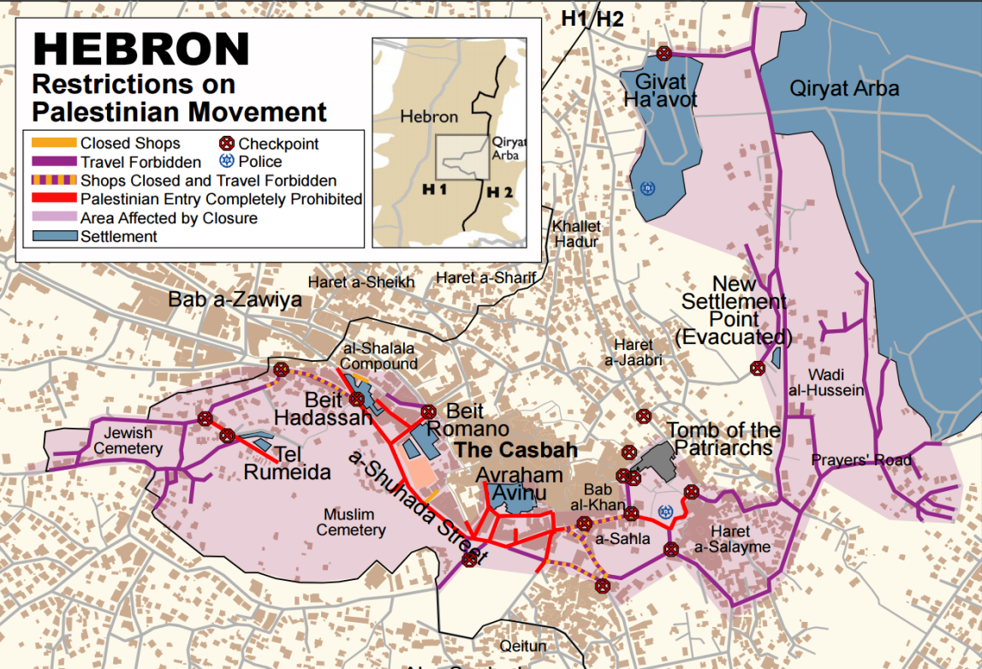
The Hebron Protocol divided the city into two sections, a) H1, which makes 80 percent of the city that came under full Palestinian control, and b) H2, which makes 20 percent – including the four Jewish settlements and Al Shuhada Street – that came under full Israeli control. Approximately 40,000 Palestinians are still living in H2 under Israeli control and side by side with Israeli settlers which causes casualties between the two populations, which is against the object and purpose of Art. 49 (paragraph 6) of the Fourth Geneva Convention.
In the aftermath of the Second Intifada (2000)
After increased tensions in 2000 between Palestinian demonstrators and the IDF (the Second Intifada), the ban on Palestinian traffic to Al Shuhada Street was expanded by including Palestinian pedestrians as well. Streets in downtown Hebron – adjacent to the Al Ibrahimi Mosque and the Jewish settlements – were and still are shut to Palestinian motorists. According to the Israeli non-governmental organisation (NGO) B’Tselem, 1,829 Palestinian shops in downtown Hebron are still closed due to these restrictions, and some 1,150 apartments in the area have been left by their Palestinian owners and became absentee property. The windows of apartments that remain inhabited are covered with metal cage to protect them from stones thrown by settlers and the front doors are permanently closed by the IDF forces so that their owners have to enter their houses from their backyard which is on another street. Currently, only a few Palestinians families are still in Al Shuhada Street despite the fact that they have to cross two checkpoints (Bab Al Zaweyya and Gilbert checkpoints) to reach or leave their homes and are regularly being attacked by settlers.
These few Palestinian families living in Al Shuhada Street have a handwritten number on their green ID (the colour for West Bank residents) to prove at the checkpoints that they live there because otherwise they would not be allowed into the street. Palestinians other than those who live in Al Shuhada Street are not allowed to enter this area, not even family or friends of the Palestinian residents of Al Shuhada Street. Children from area H1 who go to the Palestinian school in Al Shuhada Street (H2) first have to cross the Bab Al Zaweyya checkpoint to enter the street and then another checkpoint at the entrance of the school. Due to the lines that occur every morning, these children often are too late for their classes.

Pictures from Al Shuhada Street:
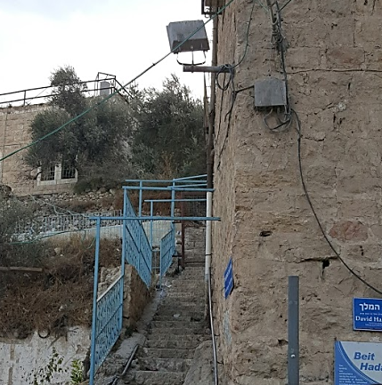

The checkpoint to the Palestinian school in Al Shuhada Street, photo taken during a weekend (November 2016).

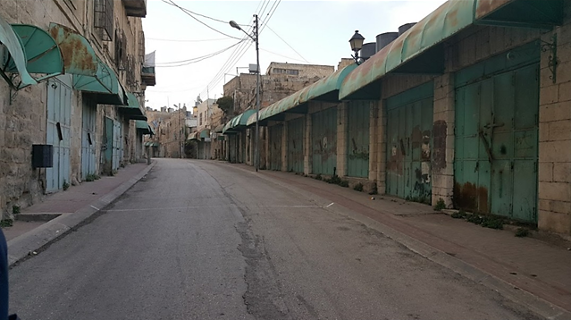
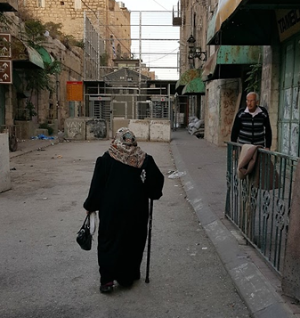
Elderly people crossing the Bab Al Zaweyya Checkpoint to enter Al Shuhada Street (H2), photo taken from H1 (November 2016).
Al Shuhada Street from within (H2), visible on the picture are the Palestinian shops shut down and homes left after the Goldstein Massacre in 1994 (November 2016).

Tel Rumeida: closed military area
Since November 2015, the neighbourhood to which Al Shuhada Street belongs, Tel Rumeida, where approximately 2,000 Palestinians live, has been declared a closed military area. The Bab Al Zaweyya checkpoint is the main access point to this area from H1. This checkpoint ensures ultimate protection to the settlers who now (partly) inhabit the abandoned Palestinian houses. The checkpoint has high metal fences and doors, automated metal turnstiles, metal detectors and a military lookout point. During religious celebrations of Israeli settlers and their visitors, the area is entirely closed off to Palestinians, leaving some locked in their homes and others unable to return home. None the less, even on regular days these checkpoints are often arbitrarily closed without notification.
Although international human rights law is not the legal regime that is used for this thesis, it is noteworthy that these examples are singly violating the basic human rights of the Palestinians which the occupant is responsible for ensuring them from (e.g. freedom of movement, freedom of education etc.). As for the law of occupation, these examples show the effective control that Israel has over the Palestinian territories and the presence of its own military force on the ground. The settlements are inhabited by Israeli civilians who are fully protected by the IDF. The settlements and settlers cause flagrant damages to the Palestinians. Interviews taken with Palestinians in H2 establish that they are not safe nor do they enjoy life. Those who are able and willing to leave are forced to do so, yet others stay as they believe that the occupation will end one day.

Inducement and facilitation by the occupant
By building these settlements and creating a desirable environment for potential settlers, Israel does induce and facilitate Jews from all around the world to come and stay at the illegal Israeli settlements in the West Bank. The living costs in the settlements are much lower whereas the subsidies per person are higher than in Israel. Also, the Israeli Ministry of Education spends more per pupil in the settlements than it does in Israel (almost twice as much). The low density, pleasant nature and working possibilities – cumulating with ideological, religious and political reasons – do attract Israelis to the West Bank.Besides, the settlements and settlers are also protected by any means because they live in closed areas (at some places literally closed by ‘the Wall’) and have their own roads as mentioned above.
The inducement and facilitation goes together with advertisements at the International airport in Tel Aviv. At the Ben Gurion International airport, there are booklets available for free – in the light of the celebrations of 120 years of Zionism – which are inviting (only) Jews from all around the world to settle in Israel. Openly normalising the issue of settlements – ignoring the legal status of the Palestinian territories – Israel announces that:

‘The settlements were established in outlying areas in order to diffuse the population as widely as possible and to protect Israel’s borders. The distribution of the settlements created and continues to form the basis of the country’s geographical boundaries.’

These booklets are available for every person who enters Israel via the Ben Gurion international airport, thus also for leaders and politicians of States Parties to the Fourth Geneva Convention who verbally condemn the establishment and expansion of the Israeli settlements. However, no State has yet spoken about the celebrations of Zionism that normalises the flagrant violation of Art. 49 (paragraph 6) of the Fourth Geneva Convention. In this regard, the legal consequences for third States by normalising a breach of the Fourth Geneva Convention is discussed in Chapter Four.

Conclusion
Although Art. 49 (paragraph 6) of the Fourth Geneva Convention prohibits the establishment and expansion of the Israeli settlements in the West Bank, the establishment for military purpose is a legally valid exception. The Hague Regulations do not explicitly provide such a provision, but regarding its object and purpose, it fits in the context of the Hague Regulations. The Israeli Supreme Court establishes that settlements can be established for military purposes only, safe when it is for temporary use and subject to compensation. This is also confirmed in the Fourth Geneva Convention and by the ICJ.
The case of Hebron shows that the Israeli settlements are not (all) necessary built for military purposes, neither for temporary use. Therefore, those settlements are illegal under Art. 49 (paragraph 6) of the Fourth Geneva Convention. Furthermore, Israel’s national law is not in accordance with its obligations under the law of occupation. Finally, the bilateral agreements between Israel and Palestine are insufficient to create another exception to Art. 49 (paragraph 6). Hence, Israel must comply with Art. 49 (paragraph 6), yet it openly refuses to do so. Chapter Four discusses the legal consequences of Israel’s violation of international law, both for Israel itself and for third States.

- Legal consequences

  - Introduction
Chapter Two establishes the applicability of the law of occupation and the Fourth Geneva Convention in the West Bank. Chapter Three establishes that the Israeli settlements in the West Bank – since 1967 – do violate Art. 49 (paragraph 6) of the Fourth Geneva Convention. According to the ARSIWA, ‘every violation of a rule of international law entails the international responsibility of the State that has committed it’. Being a State Party to the Fourth Geneva Convention, Israel bears the responsibility to respect and implement its international obligations under this Convention. Therefore, it must rectify and end the consequences resulting from the violation of Art. 49 (paragraph 6).
This Chapter sets out the legal consequences for Israel (Section 4.2.) and for third States (Section 4.3.) deriving from the violation of Art. 49 (paragraph 6). The ICJ Wall and Namibia advisory opinions, in which these legal consequences are examined, make an important part of the discussion in this regard. For the ICJ sets out the legal consequences for Israel, third States and also the UNSC. Yet this Chapter discusses decisions of the UNSC only as far as these concern the enforcement of Israel’s compliance with Article 49 (paragraph 6). Furthermore, the ARSIWA – as a codification of generally applicable rules of customary international law on State responsibility – is an important legal source which allows both injured States and (non-injured) third States to invoke Israel’s international responsibility. Therefore, the ARSIWA also makes an important part of the discussion.
Although the individual criminal responsibility of the settlers in the West Bank – as a legal consequence of them being part of the violation of Art. 49 (paragraph 6) by Israel – is a relevant and interesting discussion in itself, this Chapter is restricted to discuss Israel’s responsibility as a State.

Legal consequences for Israel
In the Wall advisory opinion, the ICJ examines the legal consequences – both for Israel and other States – that derive from Israel’s violation of its international obligations. Although the question, in this case, concerns particularly the construction of ‘the Wall’, the ICJ answers the questions from a more general context of the Palestinian-Israeli conflict and takes into account ‘Israel’s violation of its various international obligations’. The ICJ thereby reiterates Resolution ES-10/2 of the Tenth Emergency Special Session of the General Assembly of the United Nations (UNGA), that the Israeli settlements in the West Bank – including East-Jerusalem – are ‘illegal and an obstacle to peace and to economic and social development’ demanding, therefore, ‘the complete cessation of these settlement activities’.
Thus the first and most important legal consequence for Israel is ‘to bring the illegal situation to an end’ and ‘to comply with […] its obligations under international humanitarian law […]’. Secondly, Israel should make reparation for the damage caused by the Palestinians. The predecessor of the ICJ, the Permanent Court of International Justice (PCIJ), states in the Chorzów Factory case (1928) that the principles in order to determine the amount of compensation for a violation of international law are as follows:

“Reparation must, as far as possible, wipe out all the consequences of the illegal act and re-establish the situation which would, in all probability, have existed if that act had not been committed. Restitution in kind, or, if this is not possible, payment of a sum corresponding to the value which a restitution in kind would bear; the award, if need be, of damages for loss sustained which would not be covered by restitution in kind or payment in place of it.”

The ICJ adds, in this regard, that:

‘Israel is obliged to return the land, orchards, olive groves and other immovable property seized from any natural or legal person’ or if this is materially impossible, ‘to compensate the persons in question for the damage suffered’.

Also, the ICJ states in the Namibia advisory opinion that ‘[…] a binding determination made by a competent organ of the United Nations to the effect that a situation is illegal cannot remain without consequence’. The UNSC, as a competent organ, adopted in December 2016 Resolution 2334 – for the first time in the history of the Palestinian-Israeli conflict with no use of the VETO right by a permanent member – in which it determines the illegality of the Israeli settlements in the West Bank and that they have ‘no legal validity and constitute a flagrant violation of international law’. In this regard, the UNSC demands that Israel should ‘immediately and completely cease all settlement activities in the occupied Palestinian territory’. Hence, Israel’s continued violation of Art. 49 (paragraph 6) of the Fourth Geneva Convention entails also legal consequences deriving from Resolution 2334. The UNSC – acting under Chapter VII of the UN Charter – ‘shall make recommendations, or decide what measures shall be taken in accordance with Articles 41 and 42, to maintain or restore international peace and security’. Whereas Art. 41 of the UN Charter entails measures not involving the use of force, Art. 42 of the UN Charter creates the possibility to use force by a decision of the UNSC which would oblige member States to cooperate.

    - State responsibility under the ARSIWA
The above-mentioned legal consequences (i.e. State responsibility) resulting from the violation of an international obligation are codified in the ARSIWA. According to Art. 3 of the ARSIWA, a State is responsible for its conduct – an act or omission – when this conduct forms a breach of its international obligation and the conduct is attributable to it. According to Vermeer-Künzli, the system of the ARSIWA applies ‘objective responsibility’. This means that attribution and wrongfulness are the only requirements to establish State responsibility, thus the reasons why a State acted in a certain way – causality, damage, negligence, culpa, intent – do not influence its responsibility under the ARSIWA. However, State responsibility remains a mere given as long as it is not invoked by another State.
In order to invoke State responsibility under the ARSIWA, the State that wants to do so needs to have standing, or locus standi, which is the right to invoke responsibility. This State can be the injured State itself (Art. 42 ARSIWA) or a third State with a legal interest based on the breach of an erga omnes norm (Art. 48 ARSIWA). This distinction is relevant because whereas an injured State could claim reparation for its own benefit, a third State could only claim reparation for the interest of the injured State. Besides, only injured States can take countermeasures in order to enforce the responsible State’s compliance with its international obligations. Although Art. 54 of the ARSIWA allows third States ‘to take lawful measures against that State to ensure the cessation of the breach and reparation in the interest of the injured State’, countermeasures are reserved for the injured State alone. From a historical perspective, the rule of thumb is, that only injured States can invoke State responsibility. The ICJ states in the Reparation for Injuries advisory opinion that ‘the party to whom an international obligation is due can bring a claim in respect of its breach’. Therefore, the rights of third States remain limited under the ARSIWA.
The problem that might arise for Palestine – the injured State – is its disputed statehood. Although Art. 33 (2) ARSIWA recognises the injury of an ‘entity other than a State’, Art. 33 (1) ARSIWA provides that the obligations that arise from such injury are owed to another State. Although Palestine has not yet invoked Israel’s international responsibility under the ARSIWA for any matter, this might be a very unique and interesting case regarding the scope of the ARSIWA. For according to the system of the ARSIWA as it currently is, Palestine might be entitled as an injured ‘entity other than a State’, yet it would not have the right for reparation. Neither the ARSIWA’s commentary nor the doctrine do provide a clarification in this regard so far.
As for third States, the ICTY stated in the Furundžija case (1998) and the Kupreškić case (2000) that ‘the norms of international humanitarian law are erga omnes norms and, therefore, all States have a legal interest in their observance and consequently a legal entitlement to demand their respect’. Although these are cases about criminal jurisdiction which is out of the scope of this thesis, the legal rule that derives from these cases – that international humanitarian law norms are erga omnes norms – is highly relevant for the locus standi of third States regarding State responsibility. The ICJ confirms this rule in the Wall advisory opinion – reiterating its findings from the Barcelona Traction judgement:

‘[..] that the obligations violated by Israel include certain obligations erga omnes […] such obligations are by their very nature the concern of all States’ and ‘in view of the importance of the rights involved, all States can be held to have a legal interest in their protection’.

Hence, third States have a locus standi to invoke Israel’s international responsibility under the ARSIWA based on its violation of Art. 49 (paragraph 6) of the Fourth Geneva Convention which is an erga omnes norm of international humanitarian law.
Thus the right to invoke (locus standi) follows automatically from the existence of the direct injury to a State or the legal interest of a third State. Whether there is an injury or a legal interest – and thus whether only the injured State or also third States can invoke responsibility – depends on the norm breached. According to Vermeer-Künzli, for example, ‘grave breaches of the Geneva Conventions may give standing based on a legal interest, whereas non-compliance with the Wall advisory opinion may lead to injury’. In this regard, Palestine would have locus standi based on Art. 42 ARSIWA, whereas third States would have locus standi based on Art. 48 ARSIWA, yet neither Palestine nor any other State have used their right to invoke so far. .

Legal consequences for third States
First of all, as explained above, third States have locus standi to invoke Israel’s international responsibility under Art. 48 ARSIWA based on their legal interest to ensure respect for the Fourth Geneva Convention, see above.
Apart from the ARSIWA, Common Art. 1 of the Geneva Conventions involves obligations for third States to do all in their power to ensure that international humanitarian law is respected universally. This approach was also supported by the UNSC:

‘calls upon the High Contracting Parties to the said Convention to ensure respect by Israel, the occupying Power, for its obligations under the Convention in accordance with Article 1 thereof’.

On the other hand, Art. 146 of the Fourth Geneva Convention obliges State Parties to the Convention – both Israel and third States - to:

‘enact any legislation necessary to provide effective penal sanctions for […] grave breaches of the present Convention defined in the following Article’, and to ‘take measures necessary for the suppression of all acts contrary to the provisions of the present Convention other than the grave breaches […]’.

The ICJ, in this regard, states that ‘all the States parties to the Geneva Convention […] are under an obligation […] to ensure compliance by Israel with international humanitarian law as embodied in that Convention’.
Furthermore, the ICJ sets out the legal consequences for third States in the Namibia advisory opinion and later also in the Wall advisory opinion. Although the violations in mentioned cases were different, the legal consequences remain alike. The first and most important obligation for UN member States – other than Israel – is to recognise the illegality and invalidity of the Israeli settlements and to refrain from any support or any form of assistance to Israel by the establishment of the illegal settlements in the West Bank. Although the ICJ, in both cases, leaves the determination of the exact measures to the decision of the UNSC, it gives a general advice in this regard.
In the Namibia case, South Africa was illegally occupying Namibia. The ICJ stated, therefore, that UN member States ‘are under obligation […] to abstain from entering into treaty relations with South Africa in all cases in which the Government of South Africa purports to act on behalf of or concerning Namibia’. Applying this diplomatic measure to the Palestinian-Israeli conflict would possibly result in a trade embargo towards settlements in the West Bank. According to Moerenhout, this is even an obligation when the occupant benefits from such a trade. For the transfer of the occupant’s own population to occupied territories, on the one hand, and gaining economic benefits from such illegality, on the other hand, are both violating peremptory norms of public international law.
The ICJ subsequently rules that UN member States shall not send diplomatic or special missions to the settlements in the West Bank and shall – in any case whatsoever – make it clear to Israel that ‘the maintenance of diplomatic or consular relations does not imply any recognition’ of the legality of the settlements. The same attitude is expected from third States regarding economic and other forms of relations with Israel which may recognise or normalise the illegal settlements in the West Bank.
Finally, although non-member States are not bound by the decisions of the ICJ or the UNSC, they may not expect that the United Nations or its members ‘would recognise the validity or effects of any such relationship’.

Conclusion
The ICJ sets out the legal consequences for Israel and third States in the Wall and Namibia advisory opinions. Israel’s continued violation of Resolution 2334 incurs legal consequences which are yet to be determined by the UNSC. The UNSC – acting under Chapter VII – can invoke measures to enforce Israel’s compliance with mentioned resolution and also its other violations of international law that form a threat to international peace and security. These could be diplomatic measures or measures involving the use of force (Art. 41 and 42 UNCH).
Israel should cease this violation and should repair the situation as much as possible as if the illegal situation never happened. Israel is internationally responsible for its violation under the ARSIWA and both Palestine and third States can invoke Israel’s State responsibility according to Art. 42 and 48 of the ARSIWA respectively. As for Palestine, it is yet to be determined whether it could be considered a State under the ARSIWA in order to enforce Israel to comply with its obligations under the ARSIWA. The ARSIWA is applicable when there is a breach and attribution and the invoking State has locus standi, the right to invoke. The establishment of injury (by the injured State) or a legal interest (by third States) automatically entails locus standi.
Third States are obliged to recognise the invalidity and illegality of the Israeli settlements in the West Bank. They should refrain from any support or assistance to the establishment of these settlements. Neither shall they have diplomatic, economic or any other form of relations with the settlements that would – implicitly or explicitly – recognise or normalise the illegal settlements.

Conclusion
Chapter Two establishes that Israel has effective control over the West Bank andthe West Bank is since 1967 under de facto occupation per Art. 42 of the Hague Regulations. The law of occupation and the Fourth Geneva Convention are thus applicable in the West Bank.
Chapter Three establishes that although Art. 49 (paragraph 6) of the Fourth Geneva Convention does prohibit the establishment and expansion of the Israeli settlements in the West Bank, the establishment for military purpose is a legally valid exception when it is for temporary use and subject to compensation. This is confirmed in the Fourth Geneva Convention, by the ICJ and also by the Israeli Supreme Court. A case study of Hebron shows that the Israeli settlements are not (all) necessary built for military purposes, or for temporary use. Therefore, these settlements are illegal under Art. 49 (paragraph 6) which entails international responsibility under the ARSIWA.
Chapter Four discusses the legal consequences of Israel’s violation of Art. 49 (paragraph 6) for Israel and third States. According to the ICJ – Wall and Namibia advisory opinions – Israel should cease the violation and repair the situation as much as possible as if the illegal situation never happened and third States should recognise the invalidity and illegality of the Israeli settlements in the West Bank. They should refrain from any support or assistance to the establishment of these settlements, and also from diplomatic, economic or any other form of relations with the settlements that would – implicitly or explicitly – recognise or normalise the illegal settlements. Israel’s State responsibility under the ARSIWA can be invoked, both by Palestine (Art. 42 ARSIWA) and by third States (Art. 48 ARSIWA).

Bibliography

Books
Al Rayyes N, The Israeli Settlements from the Perspective of International Humanitarian Law (Al Haq Institute, Ramallah (Palestine), 2000).
Benvenisti E, The International Law of Occupation (Main Text, 3 The Characterization of Occupation, 2nd Edition, Oxford University Press 2012).
Crawford J et al. (ed), The Law of International Responsibility (Oxford, OUP 2010).
Cryer R, Prosecuting International Crimes: Selectivity and the International Criminal Law Regime (2005).
Dikker Hupkes S D, What Constitutes Occupation? Israel as the occupying power in the Gaza strip after the Disengagement (Jongbloed 2007).
Dinstein Y, The International Law of Belligerent Occupation (The case of Israel, 1st published, Cambridge University Press 2009).
Dörmann K, Elements of War Crimes under the Rome Statute of the International Criminal Court: Sources and Commentary (ICRC, 2003).
Glahn, von G, The Occupation of Enemy Territory, a Commentary on the Law and Practice of Belligerent Occupation (University of Minnesota Press 1957).
Gordon N, Israel’s Occupation (University of California Press, 2008).
Lein Y, Land Grab: Israel’s Settlement Policy in the West Bank (B’Tselem, 2002).
Oppenheim L, International Law (7th ed., by H. Lauterpacht, 1948).
The Law of Belligerent Occupation: Basic Issues (1960).
Singer J, The Establishment of a Civil Administration in the Areas Administered by Israel (1982).
Soeterik R, De verwoesting van Palestina (Stichting Palestina Publicaties 2008) 17.
Zimmerman B, ‘Article 4’, Commentary on the Additional Protocols of June 1977 to the Geneva Conventions of 12 August 1949 (ICRC, Y. Sandoz et al. Eds., 1987).

Geiss R, a Book Review of Y. Dinstein: The International Law of Belligerent Occupation (Cambridge University Press, Cambridge 2009) 1022 German Yearbook of International Law 53, 2010.

Cases
Permanent Court of International Justice (PCIJ)
Chorzów Factory case, Merits, Judgment No. 13, 1928, P.C.I.J., Series A, No. 17.

International Court of Justice (ICJ)
ICJ, Reparation for injuries suffered in the service of the United Nations, Advisory Opinion: ICJ Reports 1949 (Reparation for Injuries).
ICJ, North Sea Continental Shelf, Judgment, ICJ Reports 1969 (Continental Shelf).
ICJ, Barcelona Traction, Light and Power Company, Limited, Second Phase, Judgment, ICJ Reports 1970 (Barcelona Traction).
ICJ, Legal Consequences for States of the Continued Presence of South Africa in Namibia, Advisory Opinion of 21 June 1971, ICJ Reports 1971 (Namibia).
ICJ, Legality of the Threat or Use of Nuclear Weapons, Advisory Opinion, ICJ Reports 1996 (1) (Nuclear Weapons).
ICJ, Military and Paramilitary Activities in and against Nicaragua (Nicaragua v. United States of America), Merits, Judgment, ICJ Reports 1986 (Nicaragua).
ICJ, Legal Consequences of the Construction of a Wall in the Occupied Palestinian Territory, Advisory Opinion, ICJ Reports 2004 (Wall AO).
ICJ Wall AO, Written Statement of the Government of Israel on Jurisdiction and Propriety (30 January 2004).
ICJ, Armed Activities on the Territory of the Congo (Democratic Republic of the Congo v. Uganda), Judgment of 19 December 2005, ICJ Reports 2005 (Armed Activities).
ICJ, Armed Activities on the Territory of the Congo (DRC v Uganda), Separate Opinion of Judge Kooijmans of 19 December 2005, ICJ Reports 2005.

International Criminal Tribunal for Yugoslavia (ICTY)
ICTY, Prosecutor v. Anto Furundzija (Trial Chamber), IT-95-17/1-T, Judgment of 10 December 1998 (Furundzija).
ICTY, Prosecutor v. Kupreskic et al. (Trial Chamber), IT-95-16-T, Judgment of 14 January 2000 (Kupreskic).
ICTY, The Prosecutor v. Naletilić & Martinović (Trial Chamber), IT-98-34-T, Judgment of 31 March 2003 (Naletilić).

Military Tribunal(s)
Nuremberg Tribunal, Trial of the Major War Criminals before the International Military Tribunal, 14 November 1945-1 October 1946 (1947) .
Nuremberg Tribunal, Trial of Wilhelm List and Others (1949) (the Hostages Trial).

Israeli Supreme Court
HCJ 610/78, Jameel Arsam Matu’a et al. v. Minister of Defence et al. (March 1979) (Beth El).
HCJ 390/79, Dweikat v. Government of Israel (October 1979) (Elon Moreh).
HCJ 606/78, Suleiman Taufiq Ayub et al. v. Minister of Defense et al., 33(2) PD 113, 127 (for English: 9 IYHR 337 (1979)) (Taufiq Ayub).
HCJ 258/79, Amira et. al. v. Minister of Defence et. al., 34(1) PD 90, 92-3 (for English: 10 IYHR 331 (1980)) (Amira).
HCJ 202/81, Tabib et al. v. Minister of Defence et al., 36(2) PD 622, 631 (for English: 13 IYHR 364 (1983)) (Tabib);
HCJ 401/88, Abu Rian et al. V. IDF Commander of Judea and Samaria, 42(2) PD 767, 770 (for English: 23 IYHR 296 (1993)) (Abu Rian).
HCJ 290/89, Juha v. Military Commander of Judea and Samaria, 43(2) PD 116, 120 (for English: 23 IYHR 323 (1993)) (Juha).

Civ. A. 1432/03, Yinon Production and Marketing of Food Products Ltd. v. Qaraan et al., 59(1) PD 345, 355-356 (Qaraan).

Treaties and conventions
ICRC, Geneva Convention Relative to the Protection of Civilian Persons in Time of War (Fourth Geneva Convention), 12 August 1949.
ICRC, Protocol Additional to the Geneva Conventions of 12 August 1949, and relating to the Protection of Victims of International Armed Conflicts (Protocol I), 8 June 1977.
ICRC, Customary International Humanitarian Law, 2005.
International Conferences (The Hague), Hague Convention (IV) Respecting the Laws and Customs of War on Land and Its Annex: Regulations Concerning the Laws and Customs of War on Land (Hague Regulations),18 October 1907.
International Law Commission (ILC), Articles on Responsibility of States for Internationally Wrongful Acts (ARSIWA), November 2001.
Israeli Military Orders (1967).
UN, Charter of the United Nations, 24 October 1945.
UN, Vienna Convention on the Law of Treaties (VCLT), 23 May 1969.
UNGA, Rome Statute of the International Criminal Court (last amended 2010), 17 July 1998.

Related documents
Geneva Conventions 1949, Travaux préparatoires, Final Record Volume III.
ICRC, International Review of the Red Cross, Jan-Feb 1994.
Klamberg M, Commentary Rome Statute, last updated 30 June 2016.

United Nations Documents
United Nations Security Council (UNSC)
UNSC Resolution S/RES/681(20 December 1980).
UNSC Resolution S/RES/497 (17 December 1981).
UNSC Resolution S/RES/2334 (23 December 2016).
UNSC Resolution S/2011/705 (11 November 2011).

United Nations General Assembly (UNGA)
UNGA Resolution A/RES/181(II) (29 November 1947).
UNGA Resolution A/RES/32/91 (13 December 1977).
UNGA Resolution A/RES/37/123 (16 December 1982).
UNGA Resolution A/RES/38/180 (19 December 1983).
UNGA Resolution A/RES/43/21 (3 November 1988).
UNGA Resolution A/RES/ES-10/2 (25 April 1997).
UNGA Resolution A/RES/ES-10/3 (15 July 1997).
UNGA Special Session on Palestine, The Origins and Evolution of the Palestine Problem: 1917-1988 (30 June 1979).

United Nations Secretary General (UNSG)
UNSG, Report of the Secretary-General of the UN pursuant to paragraph 2 of Security Council resolution 808 (1993).

International Committee of the Red Cross (ICRC)
ICRC Resolution 31IC/11/R1 (2011).

Commentaries
Clapham et al. (ed.), The 1949 Geneva Conventions - A Commentary (15 October 2015, Main Text, Part I Cross-Cutting Issues and Common Provisions, C Ensuring Compliance with the Conventions, Ch.31 Grave Breaches of the Geneva Conventions).
Pictet J S (ed.), Commentary on the Third Geneva Convention (ICRC, Geneva, 1960).

Official documents
The Balfour Declaration (2 November 1917).
The Declaration of the Establishment of the State of Israel, Official Gazette: Number 1, 1948.
The Declaration of Principles on Interim Self-Government (Oslo Accords), 1993.
The Disengagement Plan – General Outline (18 April 2004).
Protocol Concerning the Redeployment in Hebron (Hebron Protocol), 17 January 1997.

Peace agreements
Israel-Egypt, General Armistice Agreement, 1949.
Israel-Jordan, General Armistice Agreement, 1949.
Israel-Lebanon, General Armistice Agreement, 1949.
Israel-Syria, General Armistice Agreement, 1949.
Israel-Jordan, Treaty of Peace (1994).

Press releases
Knesset Press Releases, Knesset passes settlement regulation law (7 February 2017).

Legal articles
Beinin J, and Hajjar L, Primer on Palestine, Israel and the Arab-Israeli Conflict (Middle East Research and Information Project (MERIP), February 2014.
Elst, van R, Implementing Universal Jurisdiction over Grave Breaches of the Geneva Conventions, 13 LJIL (2000) 815.
Moerenhout T, The Obligation to Withhold from Trading in Order Not to Recognize and Assist Settlements and their Economic Activity in Occupied Territories (2012), International Humanitarian Legal Studies, 344-385.
Permanent Observer Mission of Palestine to the United Nations, Israel’s belligerent occupation of the Palestinian Territory, including Jerusalem and International Humanitarian Law (15 July 1999).
Vermeer-Künzli A, Invocation of State Responsibility (2014) (SHARES Research Paper 36).

Internet sources
Al Jazeera, The Second Intifada (4 December 2003). http://www.aljazeera.com/archive/2003/12/20084101554875168.html.
Al Jazeera (N. Wilson), Remembering the Ibrahimi Mosque massacre (26 February 2016) <http://www.aljazeera.com/news/2016/02/remembering-ibrahimi-mosque-massacre-160225061709582.html>
B’Tselem, Hebron City Centre (1 January 2011).
http://www.btselem.org/hebron.
B’tselem, Checkpoints, Physical Obstructions, and Forbidden Roads (last update 8 February 2017).
http://www.btselem.org/freedom_of_movement/checkpoints_and_forbidden_roads.
B’Tselem, Area C.
http://www.btselem.org/topic/area_c.
BBC News, Bowen, J., 1967 war: Six days that changed the Middle East (5 June 2017).
http://www.bbc.com/news/world-middle-east-39960461.
Breaking the Silence, Tour in Hebron by ex IDF soldiers who served in Hebron (video, from 25:00 on).
https://www.youtube.com/watch?v=TGbV_rXmS1M.
Buch G R et al., Encyclopaedia Britannica, Palestine (last updated 12 May 2017). https://www.britannica.com/place/Palestine.
Guarnieri M, Israeli settlers lured by subsidies (23 August 2012). http://www.aljazeera.com/indepth/features/2012/08/201282211420708214.html.
ICRC, What are jus ad bellum and jus in bello? (22 January 2015) https://www.icrc.org/en/document/what-are-jus-ad-bellum-and-jus-bello-0.
ICRC, State Parties List, Israel (1951), Palestine (1982).
https://ihl-databases.icrc.org/applic/ihl/ihl.nsf/States.xsp?xp_viewStates=XPages_NORMStatesParties&xp_treatySelected=380.
International Solidarity Movement, Israeli soldiers close key checkpoint in Hebron (31 December 2014).
https://palsolidarity.org/2014/12/video-israeli-soldiers-close-key-checkpoint-in-hebron/.
Jordan Annexed West Bank after 1948 War http://www.palestinefacts.org/pf_1948to1967_jordan_annex.php.
Klein J, A visit to the grave of the mass-murderer Baruch Goldstein (4 July 2013).
http://mondoweiss.net/2013/07/murderer-baruch-goldstein/.
Mapping the Apartheid, Hebron – military zone.
https://www.hebronapartheid.org/index.php?glossary=military-zone.
Mapping the Apartheid, Al Shuhada Street – Hajez Bab A-Zawiya (Checkpoint 56). https://www.hebronapartheid.org/index.php?map=1.
Melman Y, Liberman unveils new ‘Carrot and Stick’ policy for West Bank Palestinians (17 August 2016).
http://www.jpost.com/Arab-Israeli-Conflict/Liberman-unveils-new-carrot-and-stick-policy-for-West-Bank-Palestinians-464360.
New York Times, Israel Passes Provocative Law to Retroactively Legalize Settlements (6 February 2017.
https://www.nytimes.com/2017/02/06/world/middleeast/israel-settlement-law-palestinians-west-bank.html?mcubz=0.
Teacher L, The Elements of State Responsibility International Law Essay (November 2013).
https://www.lawteacher.net/free-law-essays/international-law/the-elements-of-state-responsibility-international-law-essay.php?cref=1.
Telegraphy Agency, News Brief: Netanyahu: Mideast turmoil necessitates Israeli presence in West Bank (30 June 2014).
http://www.jta.org/2014/06/30/news-opinion/united-states/netanyahu-mideast-turmoil-necessitates-israeli-presence-in-west-bank#.U7JBLNRfhMI.twitter.
The World Zionist Organization, Exhibition: Israel celebrates 120 years of Zionism after the First Zionist Congress in Basle (August 1897).
https://unitedwithisrael.org/ben-gurion-airport-celebrates-120-years-of-zionism/.
Times of Israel (E. Miller), Two decades after massacre, Hebron is still hurting (25 February 2014).
http://www.timesofisrael.com/two-decades-after-massacre-hebron-is-still-hurting/.
UNOCHA, Fragmented Lives: Humanitarian Overview 2015, Movement and Access Restrictions (13 June 2016).
https://www.ochaopt.org/content/2015-overview-movement-and-access-restrictions.
UNOCHA, Israeli Demolition Orders against Palestinian Structures in Area C (1988-2016).
http://data.ochaopt.org/demolitions/index.aspx?id=311650.
UNOCHA, Occupied Palestinian Territory – Profile, Water, Sanitation and Hygiene (last update 15 June 2017).
https://public.tableau.com/profile/ocha.opt#!/vizhome/WASH_VPP/DashAccessland.
UNOCHA, The isolation of Palestinians in the Israeli-controlled area of Hebron city continues (13 April 2017).
https://www.ochaopt.org/content/isolation-palestinians-israeli-controlled-area-hebron-city-continues#_ftn1.
Visualizing Palestine, The Israeli ID-system (7 June 2014).
http://visualizingpalestine.org/visuals/identity-crisis-the-israeli-id-system.
Women for Human Rights and Against the Occupation, Prohibitions, Blocks and Roads Forbidden to Palestinians (Permanent prohibitions, number 13). https://machsomwatch.org/en/node/51685.
Zahriyeh E, Maps: The occupation of the West Bank (4 July 2014).
http://america.aljazeera.com/multimedia/2014/7/west-bank-security.html.

Special thanks to the Hebron University and Sam Bahour for guiding me through my research in Hebron…

The World Zionist Organization, Exhibition: Israel celebrates 120 years of Zionism after the First Zionist Congress in Basle (August 1897) <https://unitedwithisrael.org/ben-gurion-airport-celebrates-120-years-of-zionism/> accessed 16 July 2017.
The Balfour Declaration (2 November 1917) <file:///C:/Users/Semra%20Altuntas/Downloads/The_Balfour_Declaration.pdf> accessed 16 July 2017.
UNGA resolution 181(II), Future government of Palestine, A/RES/181(II) (29 November 1947) <https://unispal.un.org/DPA/DPR/unispal.nsf/0/7F0AF2BD897689B785256C330061D253> accessed 16 July 2017.
J. Bowen, BBC News, 1967 war: Six days that changed the Middle East (5 June 2017) <http://www.bbc.com/news/world-middle-east-39960461> accessed 16 July 2017.
Right in this relation is disputable, yet it will not be discussed further as it falls out of the scope of this thesis.
UNGA resolution 181(II) (n 3).
UNGA Special Session on Palestine, The Origins and Evolution of the Palestine Problem: 1917-1988 (30 June 1979) <https://goo.gl/2MDWoB> accessed 16 July 2017.
J. Beinin and L. Hajjar, Primer on Palestine, Israel and the Arab-Israeli Conflict (Middle East Research and Information Project (MERIP), February 2014) <http://www.merip.org/sites/default/files/Primer_on_Palestine-Israel(MERIP_February2014)final.pdf> accessed 16 July 2017.
The 1967 war (n 4).
The Declaration of the Establishment of the State of Israel, Official Gazette: Number 1.
Tel Aviv, 5 Iyar 5708, 14.5.1948 Page 1; Israel-Egypt, General Armistice Agreement, 1949, 42 UNTS 251; Israel-Lebanon, General Armistice Agreement, 1949, ibid., 287; Israel-Jordan, General Armistice Agreement, 1949, ibid., 303; Israel-Syria, General Armistice Agreement, 1949, ibid., 327.
Y. Dinstein, The International Law of Belligerent Occupation (The case of Israel, 1st published, Cambridge University Press 2009) 13.
Israel-Jordan, General Armistice Agreement, Article V (n 8) <http://www.mfa.gov.il/mfa/foreignpolicy/mfadocuments/yearbook1/pages/israel-jordan%20armistice%20agreement.aspx> accessed 16 July 2017.
See below the maps of the UN Partition Plan (UN Resolution 181(II)) and the borders according to the Israel-Jordan General Armistice Agreement (Rhodes Armistice Line).
Jordan Annexed West Bank after 1948 War <http://www.palestinefacts.org/pf_1948to1967_jordan_annex.php> accessed 16 July 2017.
Israel-Jordan, Treaty of Peace, 1994, 275 ILM (article 3(2)) <http://peacemaker.un.org/sites/peacemaker.un.org/files/IL%20JO_941026_PeaceTreatyIsraelJordan.pdf> accessed 16 July 2017.
The Disengagement Plan – General Outline (18 April 2004) <http://mfa.gov.il/MFA/ForeignPolicy/Peace/MFADocuments/Pages/Disengagement%20Plan%20-%20General%20Outline.aspx> accessed 16 July 2017.
S.D. Dikker Hupkes, What Constitutes Occupation? Israel as the occupying power in the Gaza strip after the Disengagement (Jongbloed 2007) 15.
UNSC resolution 2334 (2016), S/RES/2334 (23 December 2016), available from <http://www.un.org/webcast/pdfs/SRES2334-2016.pdf> accessed 16 July 2017.
Knesset Press Releases, Knesset passes settlement regulation law, Publicized: 7th February 2017 <http://www.knesset.gov.il/spokesman/eng/PR_eng.asp?PRID=13341> accessed 16 July 2017.
Geneva Convention Relative to the Protection of Civilian Person in Time of War of 12 August 1949 (Fourth Geneva Convention).
International Conferences (The Hague), Hague Convention (IV) Respecting the Laws and Customs of War on Land and Its Annex: Regulations Concerning the Laws and Customs of War on Land (18 October 1907) (Hague Regulations)
International Law Commission, Draft Articles on Responsibility of States for Internationally Wrongful Acts, November 2001, Supplement No. 10 (A/56/10).
Advisory Opinion on the Legal Consequences for States of the Continued Presence of South Africa in Namibia, International Court of Justice (ICJ), 21 June 1971 <http://www.refworld.org/cases,ICJ,4023a2531.html> accessed 16 July 2017.
Advisory Opinion Concerning Legal Consequences of the Construction of a Wall in the Occupied Palestinian Territory, International Court of Justice (ICJ), 9 July 2004 <http://www.refworld.org/cases,ICJ,414ad9a719.html> accessed 16 July 2017.
Maps available from <http://bigthink.com/strange-maps/587-maps-as-war-by-other-means> last accessed 18 June 2017.
R. Soeterik, De verwoesting van Palestina (Stichting Palestina Publicaties 2008) 17; the book is written in Dutch, yet the maps are translated into English for the purpose of this thesis.
ICRC, “What are jus ad bellum and jus in bello?” 22 January 2015 <https://www.icrc.org/en/document/what-are-jus-ad-bellum-and-jus-bello-0> accessed 16 July 2017.
Ibid.
Art. 42 of the Hague Regulations.
Art. 49 (paragraph 6) of the Fourth Geneva Convention.
ICRC, Treaties, States Parties and Commentaries to the Fourth Geneva Convention < https://ihl-databases.icrc.org/applic/ihl/ihl.nsf/States.xsp?xp_viewStates=XPages_NORMStatesParties&xp_treatySelected=380> accessed 16 July 2017.
International Committee of the Red Cross (ICRC), Protocol Additional to the Geneva Conventions of 12 August 1949, and relating to the Protection of Victims of International Armed Conflicts (Protocol I), 8 June 1977, 1125 UNTS 3 <http://www.refworld.org/docid/3ae6b36b4.html> accessed 16 July 2017; E. Benvenisti, The International Law of Occupation, (Main Text, 3 The Characterization of Occupation, 2nd Edition, Oxford University Press 2012); Dinstein (n 12) 4
B. Zimmerman, ‘Article 4’, Commentary on the Additional Protocols of June 1977 to the Geneva Conventions of 12 August 1949 (ICRC, Y. Sandoz et al. Eds., 1987) 71-73.
Benvenisti (n 33) 44; Hupkes (n 18) 18; Dinstein (n 12) 5.
Wall AO (n 25) Para 89.
Nuremberg Tribunal, Trial of the Major War Criminals before the International Military Tribunal, Nuremberg, 14 November 1945-1 October 1946 (Nurnberg, 1947) 334.
ICTY, The Prosecutor v. Naletilić & Martinović IT-98-34-T, Trial Chamber, Judgment of 31 March 2003, Para. 215 <http://www.icty.org/x/cases/naletilic_martinovic/tjug/en/nal-tj030331-e.pdf> accessed 16 July 2017.
HCJ 390/79, Dweikat v. Government of Israel (1979) (Elon Moreh case) 14.
Art. 42 of the Hague Regulations; italics added.
L. Oppenheim, International Law (7th ed., by H. Lauterpacht, 1948) 435; Benvenisti (n 33) 47; Hupkes (n 18) 20.
G. von Glahn, The Occupation of Enemy Territory, a Commentary on the Law and Practice of Belligerent Occupation (University of Minnesota Press 1957) 29; Dinstein (n 12) 21.
L. Oppenheim, The Law of Belligerent Occupation: Basic Issues (1960) 435; Hupkes (n 18) 21; Von Glahn (n 40) 28.
ICTY Naletilić (n 38) Para. 217; italics added.
ICJ, Armed Activities on the Territory of the Congo (Democratic Republic of the Congo v. Uganda), Judgment of 19 December 2005, ICJ Reports 2005, Para. 168.
R. Geiss, a Book Review of Y. Dinstein: The International Law of Belligerent Occupation (Cambridge University Press, Cambridge 2009) 1022 German Yearbook of International Law 53, 2010.
Benvenisti (n 33) 50.
Benvenisti (n 33) 51.
Armed Activities (n 45), Separate Opinion of Judge Kooijmans of 19 December 2005, ICJ Reports 2005, at 49; Benvenisti (n 33) 50; Oppenheim (n 43) 436; Hupkes (n 18) 22.
Dinstein (n 12) 6; Oppenheim (n 43) 436; Hupkes (n 18) 22.
Benvenisti (n 33) 47; Oppenheim (n 43) 171; italics added.
ICTY Naletilić (n 38) Para. 217.
United States Military Tribunal, Nuremberg, Trial of Wilhelm List and Others (the Hostages Trial), (1949) 8 LRTCWC 34, at 56.
Italics added.
Art. 4 of the Fourth Geneva Convention.
Wall AO (n 25) p 136; Hupkes (n 18) 27; Benvenisti (n 33) 110.
Ibid.
ICRC State Parties List: Israel (1951), Palestine (1982) <https://ihl-databases.icrc.org/applic/ihl/ihl.nsf/States.xsp?xp_viewStates=XPages_NORMStatesParties&xp_treatySelected=380> accessed 16 July 2017.
Ibid.
Hupkes (n 18) 25.
ICJ, Military and Paramilitary Activities in and against Nicaragua (Nicaragua v. United States of America), Merits, Judgment, ICJ Reports 1986, Para. 188; North Sea Continental Shelf, Judgment, ICJ Reports 1969, Para 73.
UNSG, Report of the Secretary-General of the UN pursuant to paragraph 2 of Security Council resolution 808 (1993), Para 35 <http://www.icty.org/x/file/Legal%20Library/Statute/statute_re808_1993_en.pdf> accessed 16 July 2017.
Elon Moreh (n 39).
Ibid., Para 90.
ICRC State Parties List (n 58).
ICRC (n 26).
Wall AO (n 25) Para 90.
ICTY Naletilić (n 38) Para 217.
UNOCHA, Fragmented Lives: Humanitarian Overview 2015, Movement and Access Restrictions (13 June 2016) <https://www.ochaopt.org/content/2015-overview-movement-and-access-restrictions> accessed 16 July 2017; B’tselem, Checkpoints, Physical Obstructions, and Forbidden Roads (last update 8 February 2017) <http://www.btselem.org/freedom_of_movement/checkpoints_and_forbidden_roads> accessed 16 July 2017.
E. Zahriyeh, Maps: The occupation of the West Bank (4 July 2014) <http://america.aljazeera.com/multimedia/2014/7/west-bank-security.html> accessed 16 July 2017.
Picture available at <http://www.timesofisrael.com/us-said-to-be-pushing-israel-to-transfer-parts-of-west-bank-to-pa/> accessed 16 July 2017.
Zahriyeh (n 70).
B’Tselem, Area C < http://www.btselem.org/topic/area_c> accessed 16 July 2017.
Ibid.
UNOCHA, Israeli Demolition Orders against Palestinian Structures in Area C (1988-2016) <http://data.ochaopt.org/demolitions/index.aspx?id=311650> accessed 16 July 2017.
UNOCHA Occupied Palestinian Territory – Profile, Water, Sanitation and Hygiene (last update 15 June 2017) <https://public.tableau.com/profile/ocha.opt#!/vizhome/WASH_VPP/DashAccessland> accessed 16 July 2017.
Ibid.
Y. Melman, Liberman unveils new ‘Carrot and Stick’ policy for West Bank Palestinians (17 August 2016) <http://www.jpost.com/Arab-Israeli-Conflict/Liberman-unveils-new-carrot-and-stick-policy-for-West-Bank-Palestinians-464360> accessed 16 July 2017; italics added.
Art. 33 of the Fourth Geneva Convention.
Jewish Telegraphy Agency, News Brief: Netanyahu: Mideast turmoil necessitates Israeli presence in West Bank (30 June 2014) <http://www.jta.org/2014/06/30/news-opinion/united-states/netanyahu-mideast-turmoil-necessitates-israeli-presence-in-west-bank#.U7JBLNRfhMI.twitter> accessed 16 July 2017.
G.R. Buch et al., Encyclopaedia Britannica, Palestine (last updated 12 May 2017) <https://www.britannica.com/place/Palestine> accessed 16 July 2017.
Article V (3) of the Declaration of Principles on Interim Self-Government (1993) (Oslo Accords) <http://cis.uchicago.edu/oldsite/sites/cis.uchicago.edu/files/resources/CIS-090213-israelpalestine_38-1993DeclarationofPrinciples_OsloAccords.pdf> accessed 16 July 2017.
Established by personal experience and from interviews with Palestinians near the settlements.
Visualizing Palestine, The Israeli ID-system (7 June 2014) <http://visualizingpalestine.org/visuals/identity-crisis-the-israeli-id-system> accessed 16 July 2017.
Dinstein (n 12) 238-239.
Article 4 of the Fourth Geneva Convention.
Dinstein (n 12) 239.
J. Singer, The Establishment of a Civil Administration in the Areas Administered by Israel (1982) 263; Dinstein (n 12) 55-56.
Dinstein (n 12) 240.
Geneva Conventions 1949 – Travaux préparatoires – Final Record Volume III <https://www.scribd.com/document/85918573/Geneva-Conventions-1949-Travaux-preparatoires-Final-Record-Volume-III> accessed 16 July 2017.
Ibid.
Art. 85 (4) (a) of Protocol I (n 33); Art. 8 (2) (b) (viii) of the Rome Statute of the International Criminal Court; italics added.
K. Dörmann, Elements of War Crimes under the Rome Statute of the International Criminal Court: Sources and Commentary (ICRC, 2003) 97.
M. Klamberg, Commentary Rome Statute (last updated 30 June 2016) <https://www.casematrixnetwork.org/cmn-knowledge-hub/icc-commentary-clicc/commentary-rome-statute/commentary-rome-statute-part-2-articles-5-10/> accessed 16 July 2017.
R. Cryer, Prosecuting International Crimes: Selectivity and the International Criminal Law Regime (2005) 274.
Wall AO (n 25) Para 120.
Permanent Observer Mission of Palestine to the United Nations, Israel’s belligerent occupation of the Palestinian Territory, including Jerusalem and International Humanitarian Law (15 July 1999).
Hague Regulations, Preamble (n 22) 632.
HCJ 401/88, Abu Rian et al. V. IDF Commander of Judea and Samaria, 42(2) PD 767, 770 (for English: 23 IYHR 296 (1993)).
Italics added.
HCJ 290/89, Juha v. Military Commander of Judea and Samaria, 43(2) PD 116, 120 (for English: 23 IYHR 323 (1993)).
HCJ 606/78 Suleiman Taufiq Ayub et al. v. Minister of Defense et al.; HCJ 610/78 Jameel Arsam Matu’a et al. v. Minister of Defence et al., (March 1979) (Beth El case); Elon Moreh (n 39).
Art. 46 Hague Regulations.
Beth El case (n 102); Elon Moreh case (n 39); Dinstein (n 12) 242-3.
Y. Lein, Land Grab: Israel’s Settlement Policy in the West Bank (B’Tselem, 2002) 49.
HCJ 606/78, Ayub et al. V. Minister of Defence et al., 33(2) PD 113, 127 (for English: 9 IYHR 337 (1979)).
HCJ 258/79, Amira et. Al. V. Minister of Defence et. al., 34(1) PD 90, 92-3 (for English: 10 IYHR 331 (1980)).
Ibid.
Art. 52 Protocol I.
Dinstein (n 12) 244.
Dinstein (n 12) 49.
Dinstein (n 12) 49-50.
Art. 47 of the Fourth Geneva Convention; Art. 4 of Protocol I.
Zimmerman ( 34) 71-73.
UNSC resolution 497 (1981), S/RES/497 (17 December 1981) <http://www.refworld.org/docid/3b00f15734.html> accessed 16 July 2017.
Wall AO (n 25) Para 75.
Civ. A. 1432/03, Yinon Production and Marketing of Food Products Ltd. v. Qaraan et al., 59(1) PD 345, 355-356.
Dinstein (n 12) 50.
Oppenheim (n 43) 17.
N. Gordon, Israel’s Occupation (University of California Press, 2008) 120.
Ibid.
Israeli Military Order 58 (23 July 1967).
Lein (n 105) 58-59.
Israeli Military Order 60 (23 October 1967).
Lein (n 105) 52-53.
HCJ 202/81, Tabib et al. v. Minister of Defence et al., 36(2) PD 622, 631 (for English: 13 IYHR 364 (1983)); Dinstein (n 12) 225-6; Gordon (n 120) 122.
Women for Human Rights and Against the Occupation, Prohibitions, Blocks and Roads Forbidden to Palestinians (Permanent prohibitions, number 13) <https://machsomwatch.org/en/node/51685> accessed 16 July 2017; Israeli Military Order (June 1994).
Israeli Military Order 363 (December 1969).
Israeli Military Order 59 (31 July 1967).
See discussion above.
Knesset (n 20).
New York Times, Israel Passes Provocative Law to Retroactively Legalize Settlements (6 February 2017) <https://www.nytimes.com/2017/02/06/world/middleeast/israel-settlement-law-palestinians-west-bank.html?mcubz=0> Knesset.
Art. 32 ARSIWA.
Teacher, L. (November 2013), The Elements Of State Responsibility International Law Essay <https://www.lawteacher.net/free-law-essays/international-law/the-elements-of-state-responsibility-international-law-essay.php?cref=1> last accessed 16 July 2017.
Beth El case (n 102); Elon Moreh case (n 39).
ICJ Wall AO, Written Statement of the Government of Israel on Jurisdiction and Propriety (30 January 2004) 25.
Art. 47 of the Fourth Geneva Convention; italics added.
Oslo Accords (n 82).
Protocol Concerning the Redeployment in Hebron (17 January 1997), Israel and PLO <http://www.mfa.gov.il/mfa/foreignpolicy/peace/guide/pages/protocol%20concerning%20the%20redeployment%20in%20hebron.aspx> last accessed 16 July 2017.
See maps below.
N. Wilson, Remembering the Ibrahimi Mosque massacre (26 February 2016) <http://www.aljazeera.com/news/2016/02/remembering-ibrahimi-mosque-massacre-160225061709582.html> accessed 16 July 2017.
Breaking the Silence, Tour in Hebron by ex-IDF soldiers who served in Hebron (video, from 25:00 on) <https://www.youtube.com/watch?v=TGbV_rXmS1M> last accessed 16 July 2017.
J. Klein, A visit to the grave of the mass-murderer Baruch Goldstein (4 July 2013) <http://mondoweiss.net/2013/07/murderer-baruch-goldstein/> last accessed 16 July 2017.
E. Miller, Times of Israel, Two decades after massacre, Hebron is still hurting (25 February 2014) <http://www.timesofisrael.com/two-decades-after-massacre-hebron-is-still-hurting/> last accessed 16 July 2017.
Ibid.
Hebron Protocol (n 139).
See map above <https://www.btselem.org/download/200705_hebron_center_map_eng.pdf> last accessed 16 July 2017.
Hebron Protocol (n 139); UNOCHA, The isolation of Palestinians in the Israeli-controlled area of Hebron city continues (13 April 2017) <https://www.ochaopt.org/content/isolation-palestinians-israeli-controlled-area-hebron-city-continues#_ftn1> last accessed 16 July 2017; Travaux préparatoires (n 90).
Al Jazeera, The Second Intifada (4 December 2003) <http://www.aljazeera.com/archive/2003/12/20084101554875168.html> last accessed 16 July 2017.
Ibid.
B’Tselem, Hebron City Centre (1 January 2011) <http://www.btselem.org/hebron> last accessed 16 July 2017.
Established by personal experience and interviews taken with Palestinians in and near Al Shuhada Street: Abeed (teacher of the Palestinian school in Al Shuhada Street), Saeed (resident of the only house in Al Shuhada Street that is on the H1 side of the Bab al Zaweyya checkpoint).
Ibid; UNOCHA (n 145).
UNOCHA (n 145).
Ibid.
Mapping the Apartheid, Hebron – military zone <https://www.hebronapartheid.org/index.php?glossary=military-zone> last accessed 16 July 2017.
Mapping the Apartheid, Al Shuhada Street – Hajez Bab A-Zawiya (Checkpoint 56) <https://www.hebronapartheid.org/index.php?map=1> last accessed 16 July 2017.
Ibid.
International Solidarity Movement, Israeli soldiers close key checkpoint in Hebron (31 December 2014) <https://palsolidarity.org/2014/12/video-israeli-soldiers-close-key-checkpoint-in-hebron/> last accessed 16 July 2017.
Council of Europe, European Convention for the Protection of Human Rights and Fundamental Freedoms.
M. Guarnieri, Israeli settlers lured by subsidies (23 August 2012) <http://www.aljazeera.com/indepth/features/2012/08/201282211420708214.html> accessed 16 July 2017.
Established by own experience.
Booklet, 120 Years of Zionism: Settlement and Agricultural Development (Ben Gurion international airport, April 2017) 13.
The 1949 Geneva Conventions - A Commentary (edited by Clapham et al., (15th October 2015), Main Text, Part I Cross-Cutting Issues and Common Provisions, C Ensuring Compliance with the Conventions, Ch.31 Grave Breaches of the Geneva Conventions) 644; Art. 1 ARSIWA.
N. Al Rayyes, The Israeli Settlements from the Perspective of International Humanitarian Law (Al Haq Institute, Ramallah (Palestine), 2000) 106.
Wall AO (n 25).
Wall AO (n 25) Para 147.
Wall AO (n 25) Para 19; UNGA Resolution A/RES/ES-10/2 (25 April 1997) <http://www.un.org/documents/ga/res/10emsp/a10emr02.htm> accessed 16 July 2017.
Wall AO (n 25) Paras 145, 149 and 150.
Wall AO (n 25) Paras 152.
Chorzów Factory case, Merits, Judgment No. 13, 1928, P.C.I.J., Series A, No. 17, p. 47.
Wall AO (n 25) Paras 153.
UNSC resolution 2334 (n 19).
Ibid.
Art. 39 UN Charter.
ARSIWA (n 23)
Art. 3 ARSIWA.
A. Vermeer-Künzli, Invocation of State Responsibility (2014) (SHARES Research Paper 36) 1 <www.sharesproject.nl> accessed 16 July 2017.
Ibid.
Ibid.
Ibid; Art. 42, 48 ARSIWA.
J. Crawford et al. (ed), The Law of International Responsibility (Oxford, OUP 2010) 942; Art. 31 ARSIWA.
Ibid; Art. 49 (1) ARSIWA.
Crawford (n 170) 942; Art. 54 ARSIWA; Chapter II ARSIWA.
Reparation for injuries suffered in the service of the United Nations, Advisory Opinion: ICJ Reports 1949, p. 174.
UNSC, Report of the Committee on the Admission of New Members concerning the application of Palestine for admission to membership in the United Nations (11 November 2011), S/2011/705 <http://www.refworld.org/docid/4ec618b52.html> accessed 16 July 2017.
Art. 33 ARSIWA.
ICTY, Prosecutor v. Anto Furundzija (Trial Judgement), IT-95-17/1-T (10 December 1998) <http://www.refworld.org/cases,ICTY,40276a8a4.html> accessed 16 July 2017; Prosecutor v. Kupreskic et al. (Trial Judgement), IT-95-16-T (14 January 2000) <http://www.refworld.org/cases,ICTY,40276c634.html> accessed 16 July 2017.
Barcelona Traction, Light and Power Company, Limited, Second Phase, Judgment, ICJ Reports 1970, p. 32, Para 33; Wall AO (n 25) Para. 155.
Vermeer-Künzli (n 166) 6.
Vermeer-Künzli (n 166) 7.
Ibid.
Jean S. Pictet (ed.), Commentary on the Third Geneva Convention (ICRC, Geneva, 1960) 18; Wall AO (n 25) Para 158.
UNSC Resolution 681, S/RES/681 (20 December 1980) <https://documents-dds-ny.un.org/doc/RESOLUTION/GEN/NR0/575/31/IMG/NR057531.pdf?OpenElement> accessed 16 July 2017; UNGA Resolutions A/RES/32/91 (13 December 1977), A/RES/37/123 (16 December 1982), A/RES/38/180 (19 December 1983) and A/RES/43/21 (3 November 1988).
Art. 146 of the Fourth Geneva Convention.
Wall AO (n 25) Para 159.
Wall AO (n 25) Paras 154-160; Namibia AO (n 24) Paras 117-127 and 133.
Wall AO (n 25) Para 160-161
Wall AO (n 25) Para 146.
Namibia AO (n 24) Paras 117-127.
T. Moerenhout, The Obligation to Withhold from Trading in Order Not to Recognize and Assist Settlements and their Economic Activity in Occupied Territories (2012), International Humanitarian Legal Studies, 344.
Ibid.
Namibia AO (n 24) Paras 117-127.
Ibid.
Ibid.

